

Tunku Abdul Rahman University College

Microcontroller Peripherals

***Flash Memory***

|  |  |  |
| --- | --- | --- |
| **Name:** | Wong Jang Sing |  |
|  |  |  |
| **Reg. No** | 15 WAR 09371 |  |
|  |  |  |
| **Programme:** | RMB 2 |  |
|  |  |  |
| **Tutor:** | Dr. Poh Tze Ven |  |
|  |  |  |
|  |  |  |

# CHAPTER I: INTRODUCTION

1.1 Objective:

Program has been written to the ARM Cortex®-M4 Microcontroller to communicate with the Embedded Flash memory interface to either perform read/program/erase operation to the Flash Memory. Result has been obtained and discussed in the following chapters.

1.2 Brief Description:

The Embedded Flash memory interface is an intermediate agent between the Cortex-M4 microcontroller and the Flash memory. Basically the microcontroller is telling the flash memory interface whether to perform read/program/erase operation to the Flash Memory. The Flash memory interface connection inside system architecture for STM32F429 is as shown below.

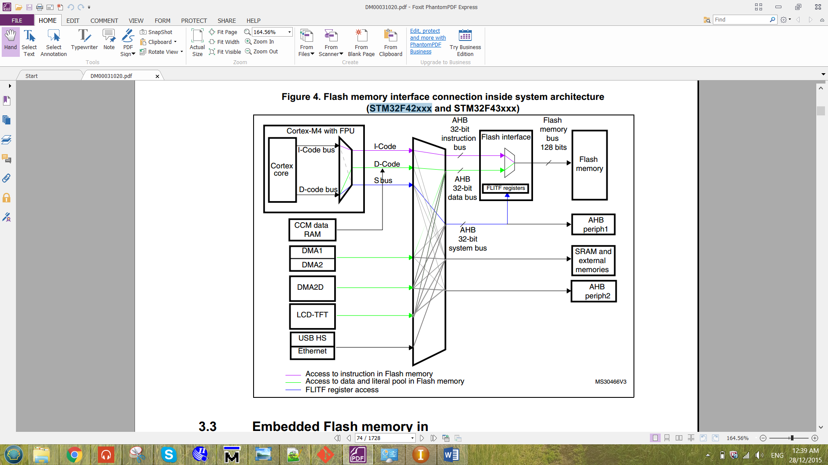

Figure 1 Flash memory interface connection inside system architecture for

The Flash memory interface manages CPU AHB (advanced high-performance bus) I-Code and D-Code accesses to the Flash memory. The I-Code and D-Code are Instruction Code and the Data Code respectively. For the I-Code, it connects the Instruction bus of the ARM microcontroller to the Flash instruction interface. While for the D-Code, it connects the D-Code bus of the ARM microcontroller to the Flash data interface. Before the flash memory interface, the data has been processed by the bus matrix. The bus matrix is as shown below.

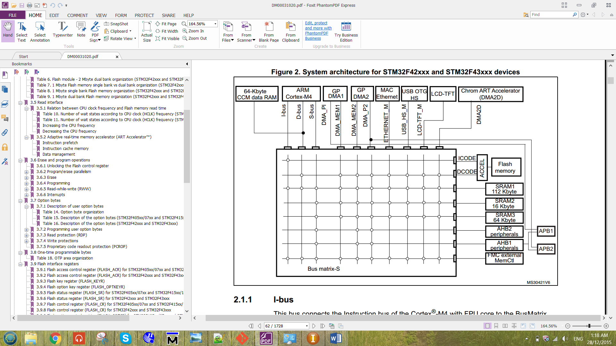

Figure 2 Bus matrix for STM32F429.

The flash memory for microcontroller STM32F429 is organized as follow:

- A main memory block divided into sectors.

- System memory

- 512 OTP (one-time programmable) bytes for user data.

- Option bytes.

The main memory block was divided into two bank with 1Mbyte. In each bank, it consists of 4 sectors with 16k bytes, 1 sector of 64k bytes and 7 sectors of 128k bytes. There are 16 additional byte in each bank which is the Option Bytes. The option bytes is to configure the read and write protection, BOR level, watchdog, dual bank boot mode, dual bank feature, software/hardware and reset when the device is in Standby or Stop mode. The STM32F429 is a device that have 2M byte with dual bank flash memory. The flash module for 2M byte dual bank organization is as shown below.

Table 1 flash module for 2M byte dual bank organization for STM32F429

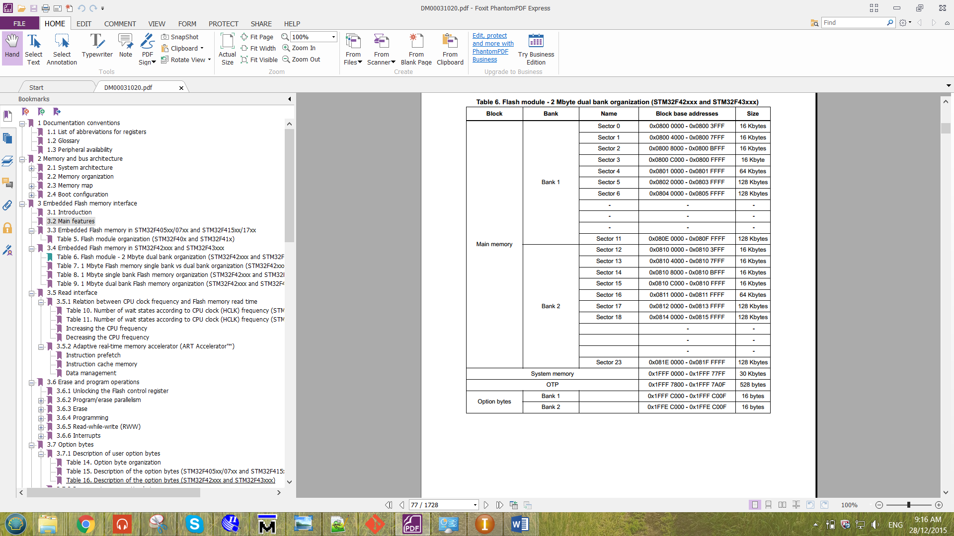

The clock used for the Flash Memory is the HCLK, which can operate up to 180MHz maximum. The clock source used to produce the HCLK is from the external clock (CRYSTAL CLOCK). The crystal clock frequency of the device is 8MHz. The overall picture the HCLK that produced to the flash memory is as shown below.

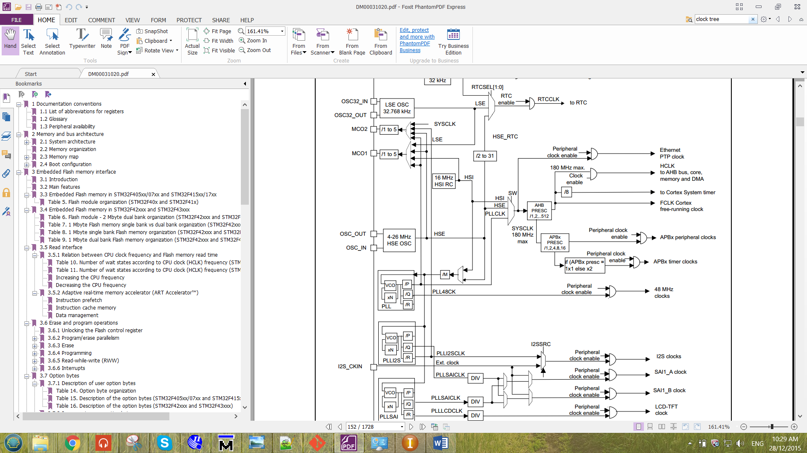

Figure 3 Clock tree for the Flash Memory.

From the figure 1.1, there are 32-bit for instruction bus and 32-bit for data bus. So the maximum bit that able to store into the Flash is 32-bit. The Flash is unable to store a 64-bit value. These will be proven in the following chapter.

1.3 Flash memory Operation

**i) Read Operation**

Reading the data at the selected address of the flash memory. If the selected address was an empty address, the data of that address will be all ‘1’ for every single bit.

**ii)** **Erase Operation**

There are three type of erase operation for the flash memory, which are sector erase, bank erase and Mass erase. After the erase operation has been done, the data in the erased address will all become ‘1’.

Sector Erase => to erase all the data in the selected sector.

Bank Erase => to erase all the data in the selected bank.

Mass Erase => to erase all the data in the Flash Memory.

Note that when the program written for the controller is booting in sector 1. So the sector 1 which is in bank 1 is unable to erase.

**iii) Program Operation**

Before programming data into an address of the flash, the particular address has to be erased only it is ready to program. Otherwise, unexpected value will be stored to the particular address selected. This happens because the flash memory of this device are only able to write a ‘0’ to the address. When they see a ‘1’, it will not make any changes to the memory data. Thus, violation may happens.

**iv) Memory-to-memory transfer by Direct Memory Access (DMA)**

With the aid of DMA, the ARM controller can now able to transfer multiple data to the flash through the streams of the DMA. Note that only DMA2 controller can be used to perform memory-to-memory transfer. The table for DMA2 request mapping is as shown below.

Table 2 DMA2 request mapping

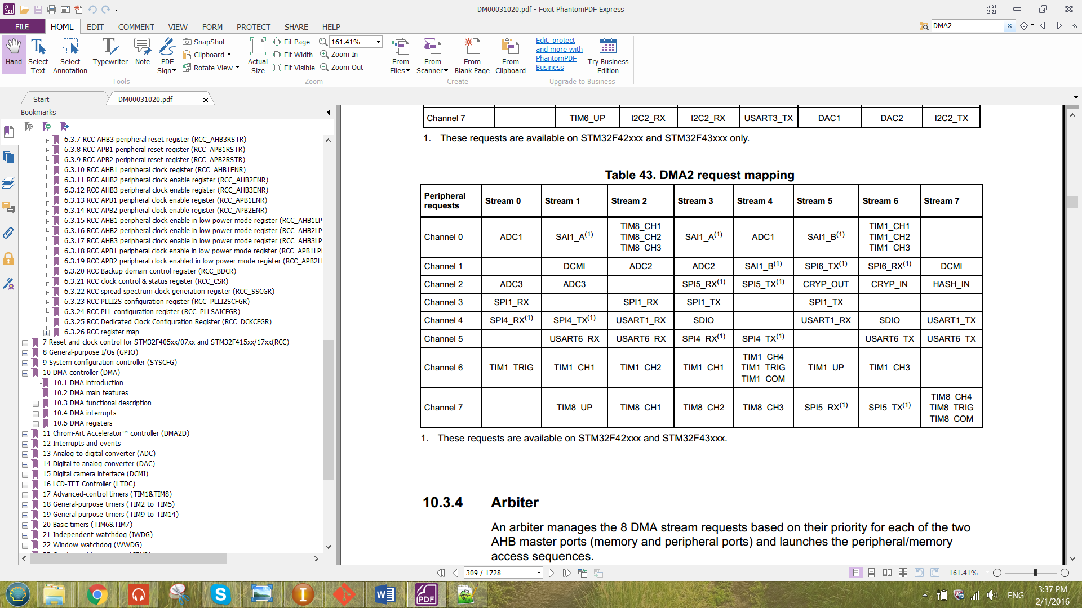

From the table above, there are no specified stream for flash memory. Thus, empty stream has to be chosen for the flash memory transfer such as St7-Ch0, St0-Ch1, St2-Ch2, St1-Ch3, St4-Ch3, St6-Ch3, St7-Ch3, St4-Ch4, St5-Ch5, St7-Ch6 and St0-Ch7. St stands for stream and Ch stands for channel.

These streams are the intermediate agent that enable the memory to flow form the RAM memory to the Flash Memory. The transfer of the data can be illustrate as shown in figure below.

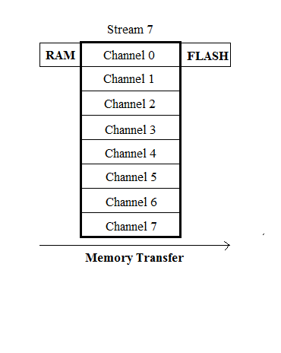

Figure 4 Memory transfer at St7-Ch0

From the Figure 4 above, it is an example of using Channel 0 of the Stream 7 to perform memory transfer from RAM memory to Flash Memory.

CHAPTER II: METHODOLOGY

In this chapter will discuss about the configuration of the flash memory. Configuration description included for unlocking Flash Control Register, read Operation, erase Operation, programming operation and DMA memory-to-memory transfer Operation

2.1 Unlocking Flash Control Register

Before performing any operation to the Flash memory interface, the flash control register (FLASH_CR) has to be unlocked by storing the key value into the flash key register (FLASH_KEYR). There are two key that has to be keyed in into the register, the sequence is as shown below.

KEY1 = 0x45670123

KEY2 = 0xCDEF89AB

The KEY1 has to be keyed into the register only followed by the KEY2. Otherwise the Flash control register will still not be unlocked.

2.2 Read Operation

For read operation of the flash memory, the wait state has to be correctly configure at the LATENCY[3:0] bit in the Flash access control register (FLASH_ACR). The number of wait states are configured depending on the clock frequency (HCLK) and the voltage supplied of the device. The number of wait state to be configure can be refer to the figure below.

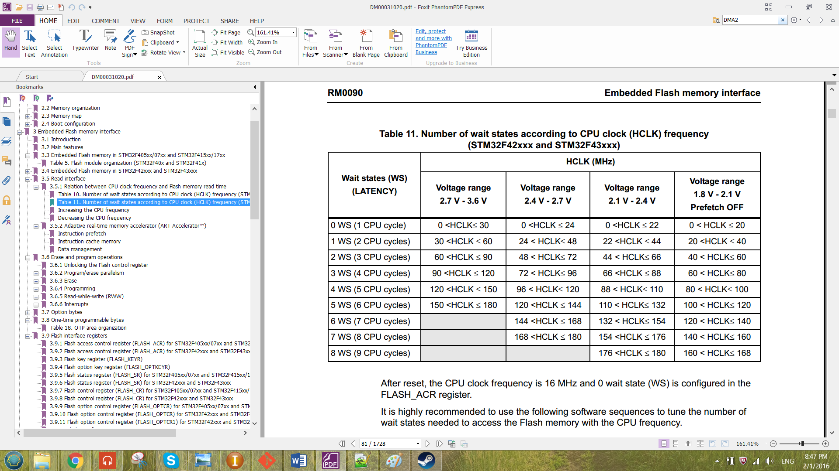

Figure 5 Number of wait states according to CPU clock (HCLK) frequency

2.3 Erase Operation

1. Check whether the Flash memory interface is busy by checking the BSY bit in the Flash status Register (FLASH_SR).
2. **For Sector Erase,**

* Setting the number of SNB bit in FLASH_CR to choose which sector to erase.

**For Bank Erase,**

* Setting MER or MER1 in FLASH_CR bit to choose which bank to erase. MER for bank1 and MER1 for bank2.

**For Mass Erase,**

* By setting MER and MER1 bit in FLASH_CR to erase both bank.

1. Set the STRT bit in FLASH_CR register to start erasing.
2. Wait BSY bit to be cleared.

***2.4*** Programming Operation

1. Check whether the Flash memory interface is busy by checking the BSY bit in the Flash Status Register (FLASH_SR).
2. Setting PG bit in Flash Control Register (FLASH_CR) to enable programming.
3. Set parallelism size (x8, x16, x32 and x64) by configuring the PSIZE[1:0] bit of the FLASH_CR register. Parallelism size shows the number of bits to be program to the flash.
4. Wait BSY bit to be cleared.

2.5 DMA memory-to-memory transfer Operation

The data transfer direction has been set to be memory-to-memory from the DIR[1:0] it of the DMA_SxCR. The memory data size MSIZE[1:0] and the peripheral data size PSIZE[1:0] has been configured depends on the number of bits of each data memory to be transferred. The priority has set to be very high at the bit PL[1:0]. The TCIE bit in DMA_SxCR has been enabled so that after the transfer been completed, it will enable the interrupt flag CTCIFx at the register DMA high interrupt flag clear register (DMA_HIFCR)

For the single memory transfer, the stream and the channel number has to be configure properly. The stream is selected by offsetting the address by using the formula below.

**Address offset:** Register Offset + 0x18 × stream number

The register offset shows the address to be offset for each specific register. The 0x18 of address includes the configuration register (DMA_SxCR), data register (DMA_SxNDTR), peripheral address register (DMA_SxPAR), memory 0 address register (DMA_SxM0AR), memory 1 address register (DMA_SxM1AR) and FIFO control register (DMA_SxFCR). Each of the register takes 0x04 of the address. The Channel number is selected by configuring the CHSEL[2:0] bits in the DMA_SxCR register.

For multiple memory transfer, PINC bit and the MINC bit of the DMA_SxCR has to be set. These bits has to be set to increment the address pointer of peripheral (DMA) and the address pointer of memory (Flash Memory) after each memory has been transfer.

After all configuration has been done, the DMA has been enabled by setting the EN bit in the DMA_SxCR register.

# CHAPTER III: RESULT & DISCUSSION

In this chapter will show the result for all the operation that has been discussed in the previous chapter and how to configure by using the C programming language to program into the ARM Cortex®-M4 Microcontroller. The written program was compiled and debugged by the software CooCox CoIDE version 2.0.3.

The data structure created for the embedded flash memory interface is as shown below.

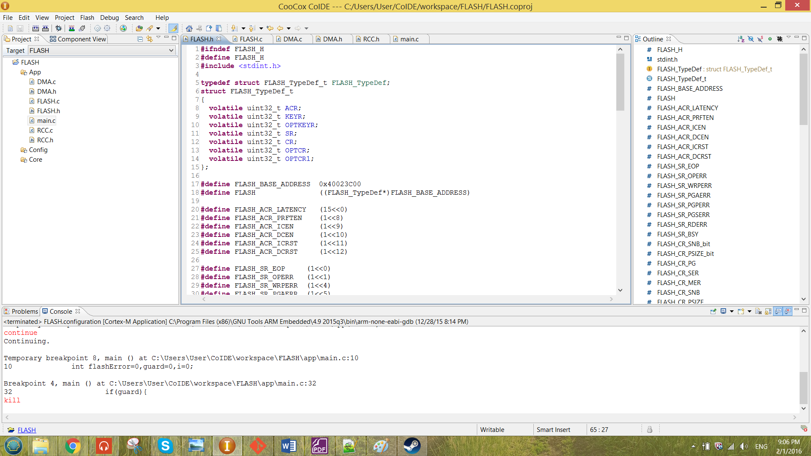

Figure 6 Data Structure of the embedded flash memory interface

The base address for the embedded flash memory interface is 0x40023C00. Hence, macros has been created to represent the base address for the embedded flash memory interface.

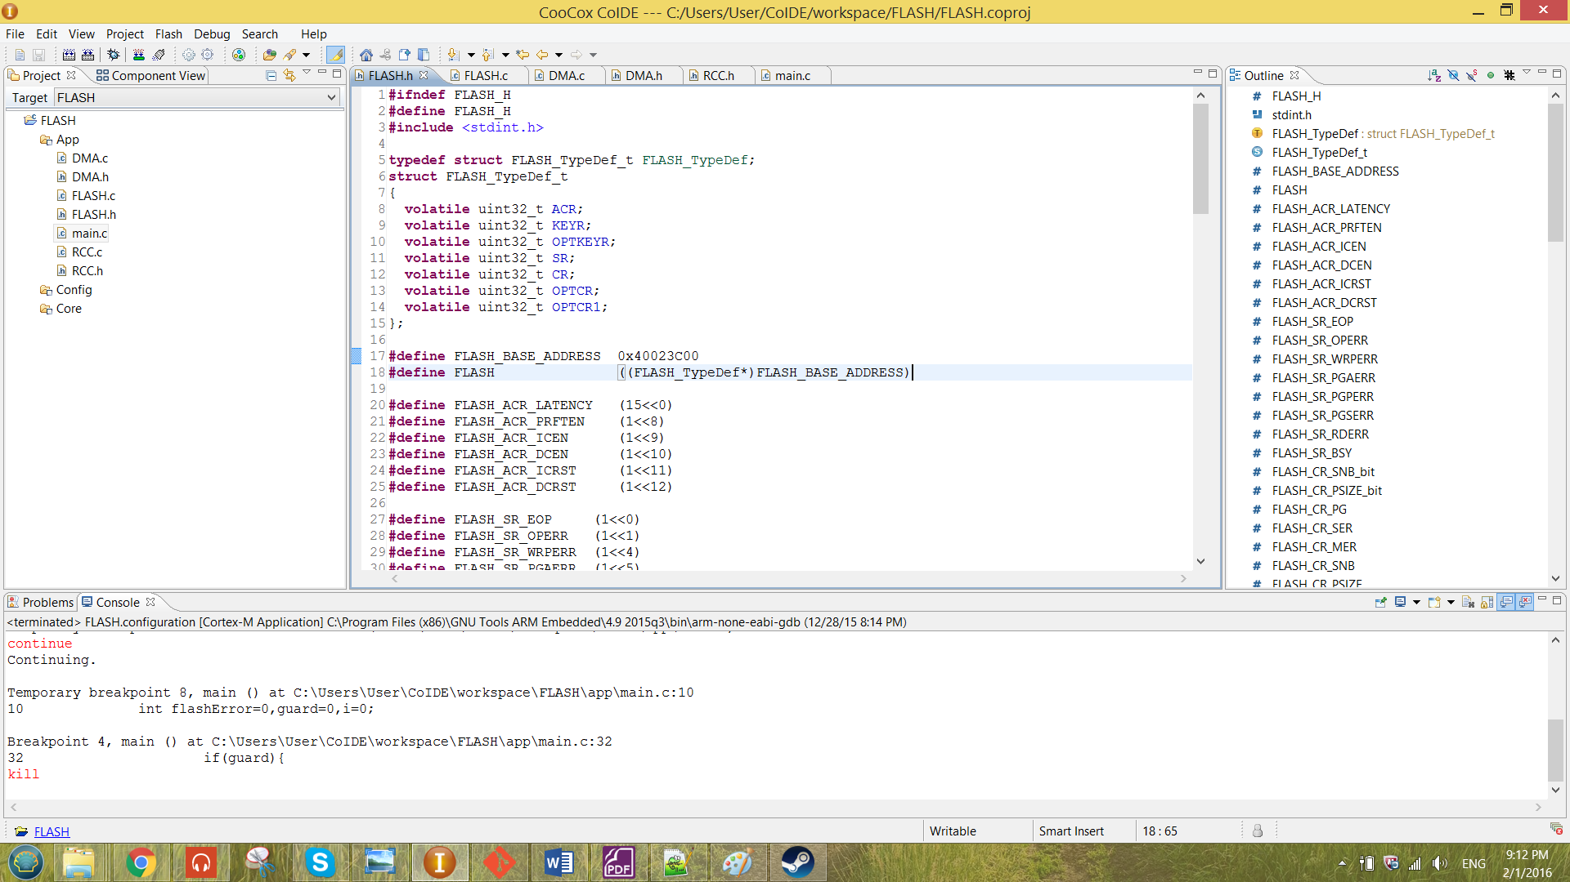

Figure 7 macros created to represent the base address of flash

From Figure 7, the macro FLASH is now pointing to the data structure that been created in Figure 6. All the element inside the data structure is declared with the type **volatile uint32_t**. By doing that, each element of the data structure will be having the size 0x4 which will give an offset of 0x4 between to element in the data structure. All the element inside the data structure represent the existence register of the embedded flash memory interface.

3.1 Unlocking Flash Control Register

From the previous chapter, the FLASH_CR can be unlocked by storing the sequence KEY1 and KEY2 into FLASH_KEYR register. The program function written is as shown below.

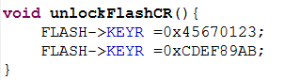

Figure 8 unlockFlashCR function

The function shown in figure 8 has been called in the main. The sequence has to be the same as above otherwise the FLASH_CR will be not unlocked. When the incorrect sequence has been keyed in, the compiler will be caught in the infinity loop as shown below.

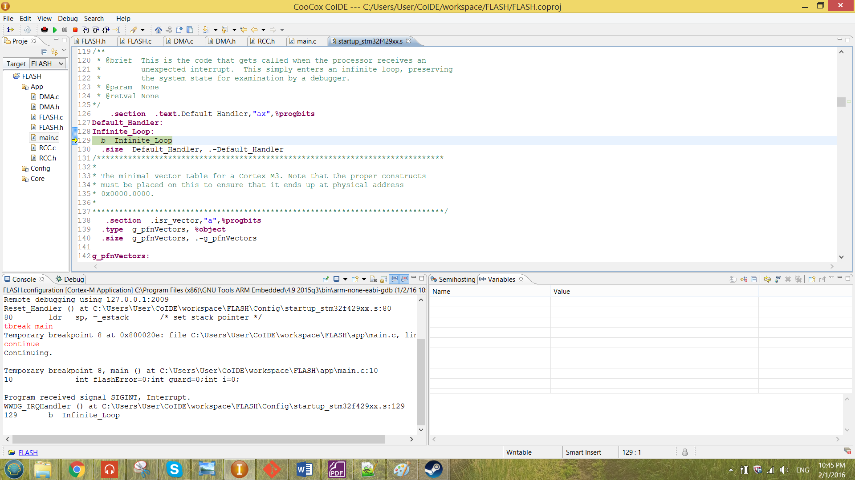

Figure 9 infinity loop caught by the compiler

When the correct KEY sequence has been keyed into the register, the LOCK bit in the FLASH_CR will be become ‘0’ which means the control register has been unlocked.

The value in the flash register has been checked by the function checkFlashReg. The function will check the value in the SR reg, CR reg and the OPTCR reg. The function checkFlashReg is as shown below.

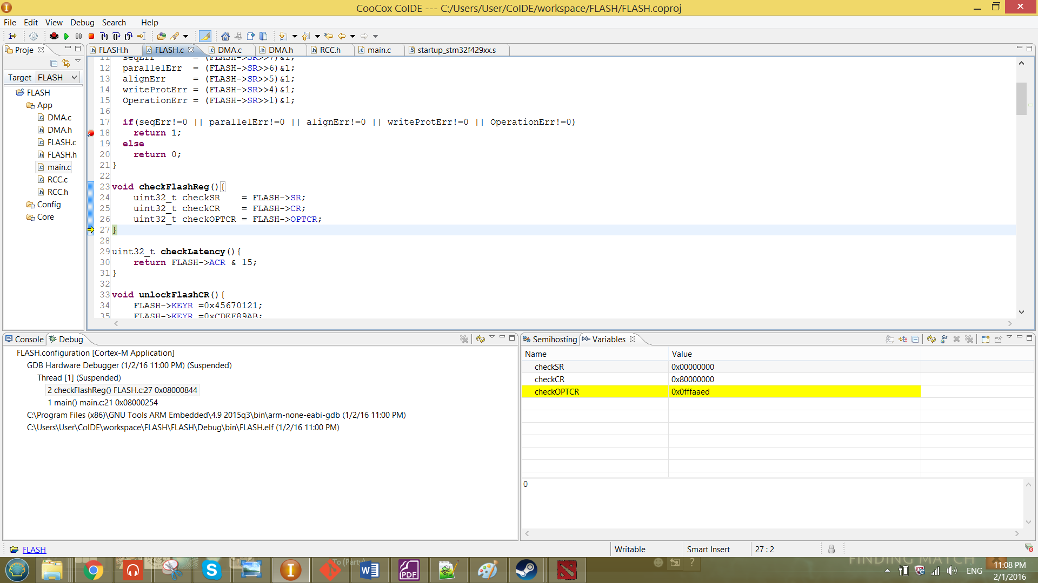

Figure 10 function checkFlashReg

The register has been checked before it unlock and after it unlock. The scenarios are as shown in figures below.

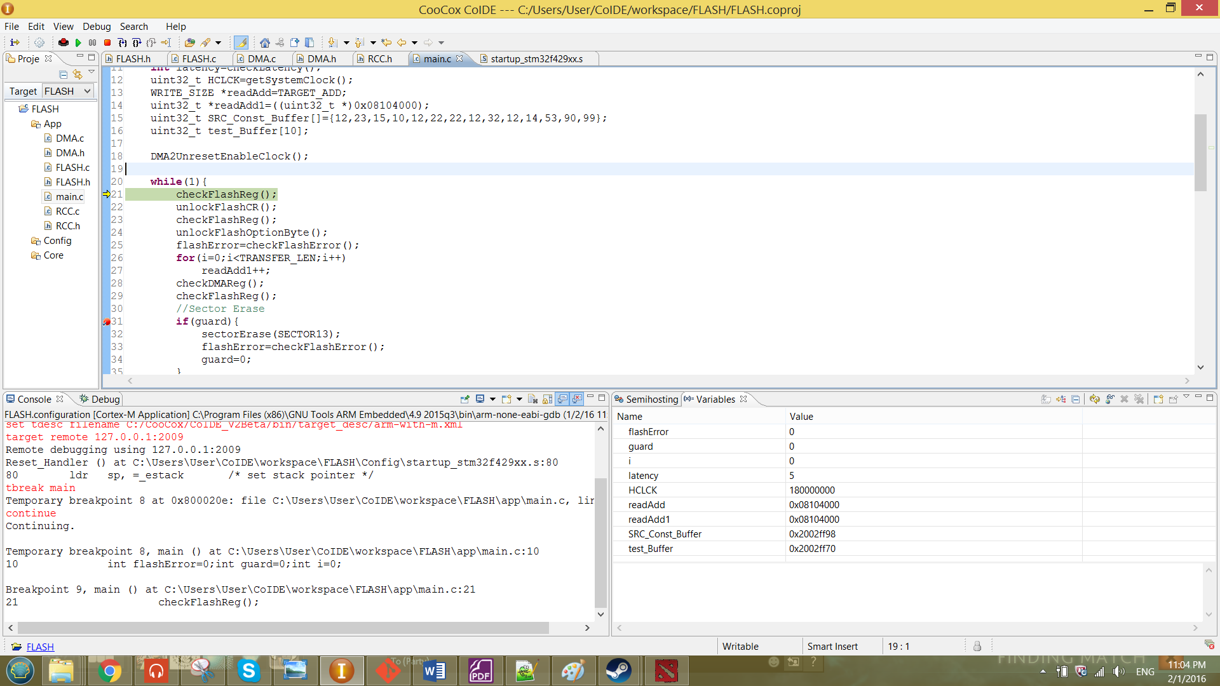

Figure 11 unlockFlashReg function called in the main

Value of CR reg before: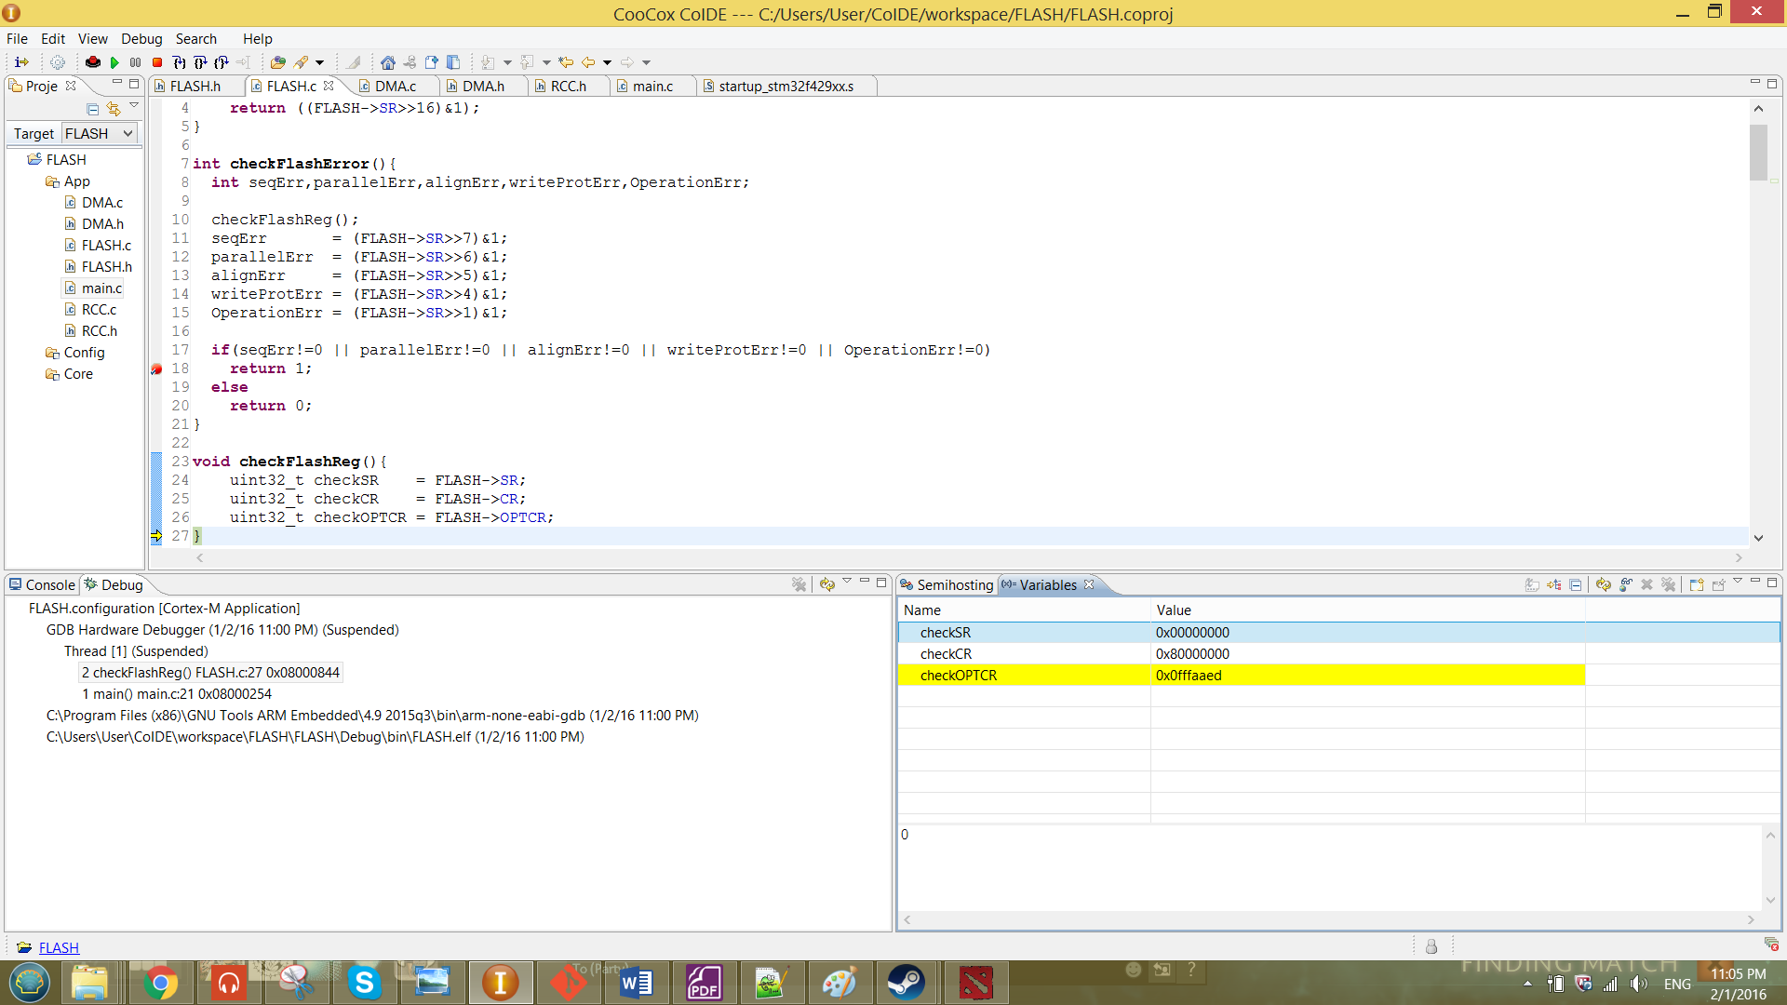

Value of CR reg after:

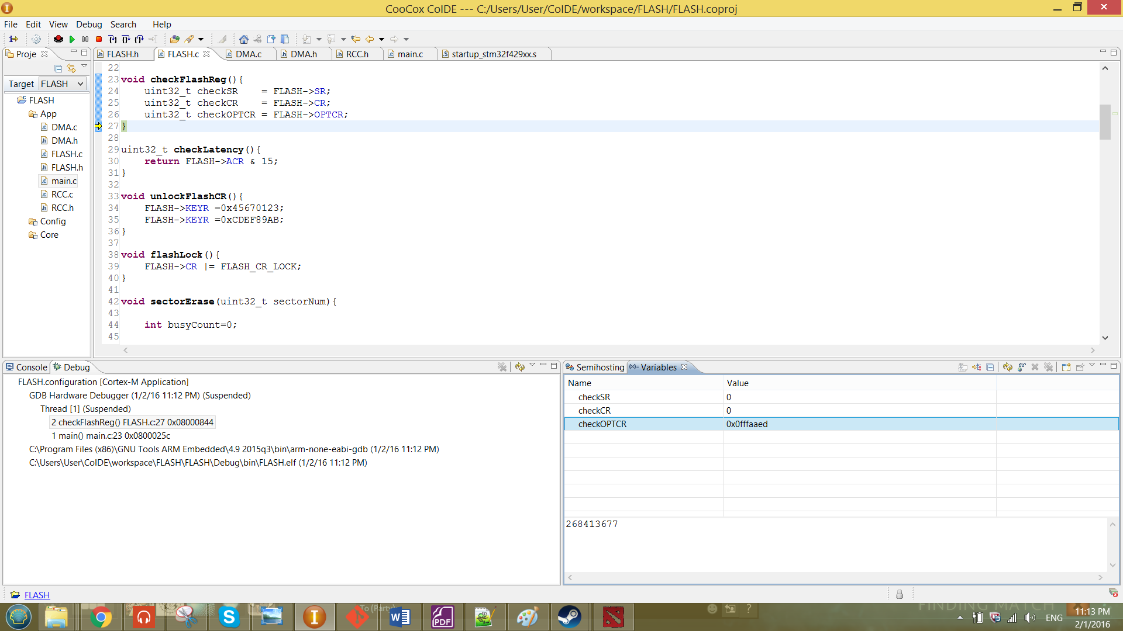

From the result shown above, the CR has been successfully unlocked by looking at the value after of the CR reg is zero. Which means that the LOCK bit has been set to zero.

2.2 Read Operation

For the read operation, the frequency of the clock (HCLK) has been obtained by the function getSystemClock. The function is obtained from the Steven’s project. This function is only to determine the HCLK frequency that produced to the flash memory interface. The function is a shown in the figure below.

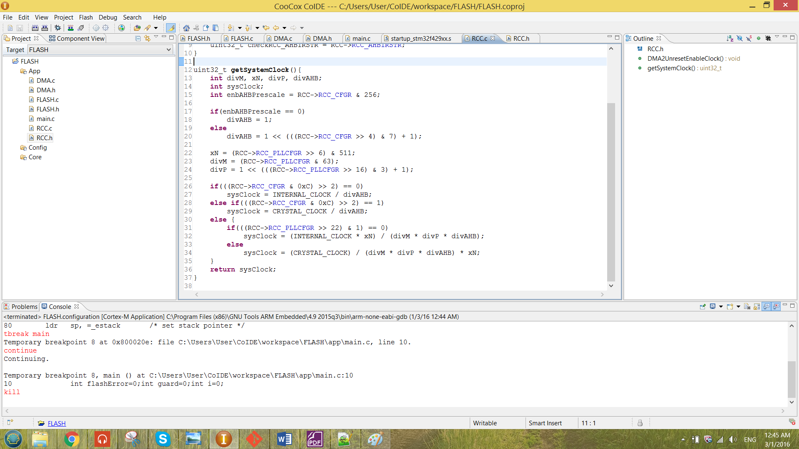

Figure 12 function getSystemClock

The function has been called in the main to determine the clock frequency. The function been called is as shown below.

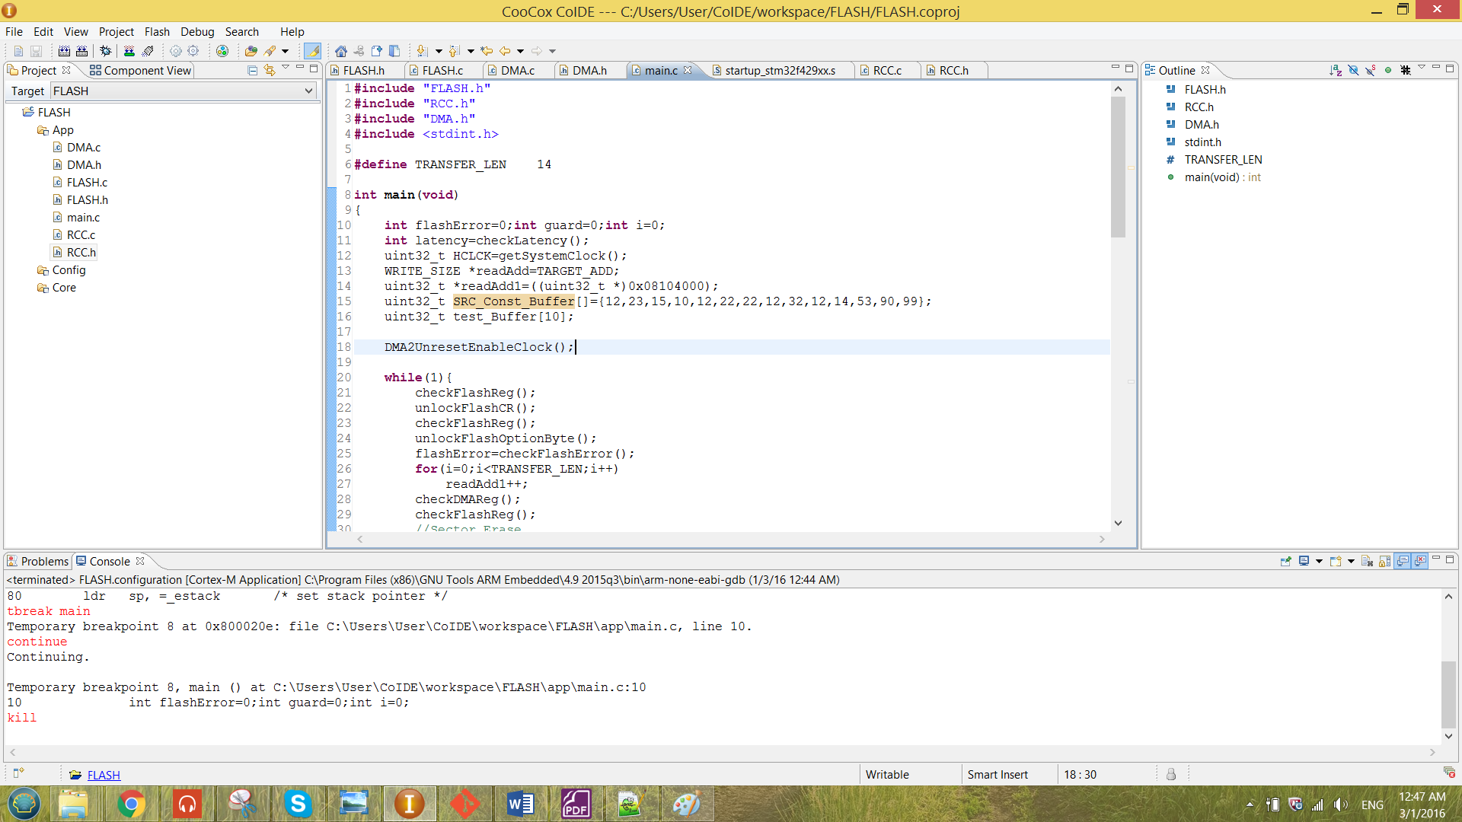

The value of the clock frequency will be stored at HCLK. The value shows after debugging is as shown below.

Table 3 value for the beginning of the debugging process

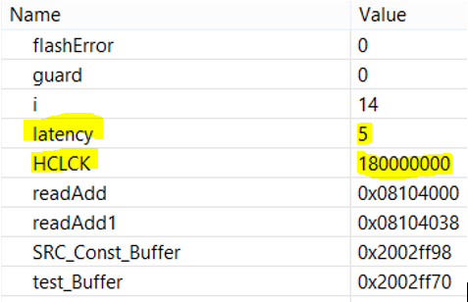

From the result obtained above, the HCLK was 180 MHz. The HCLK was obtained from the external crystal clock that passed through many divider which can refer to the figure 3.The divider includes the M, P, xN and AHB prescaler.

The wait state (LATENCY) also has been checked by using the function as shown below.

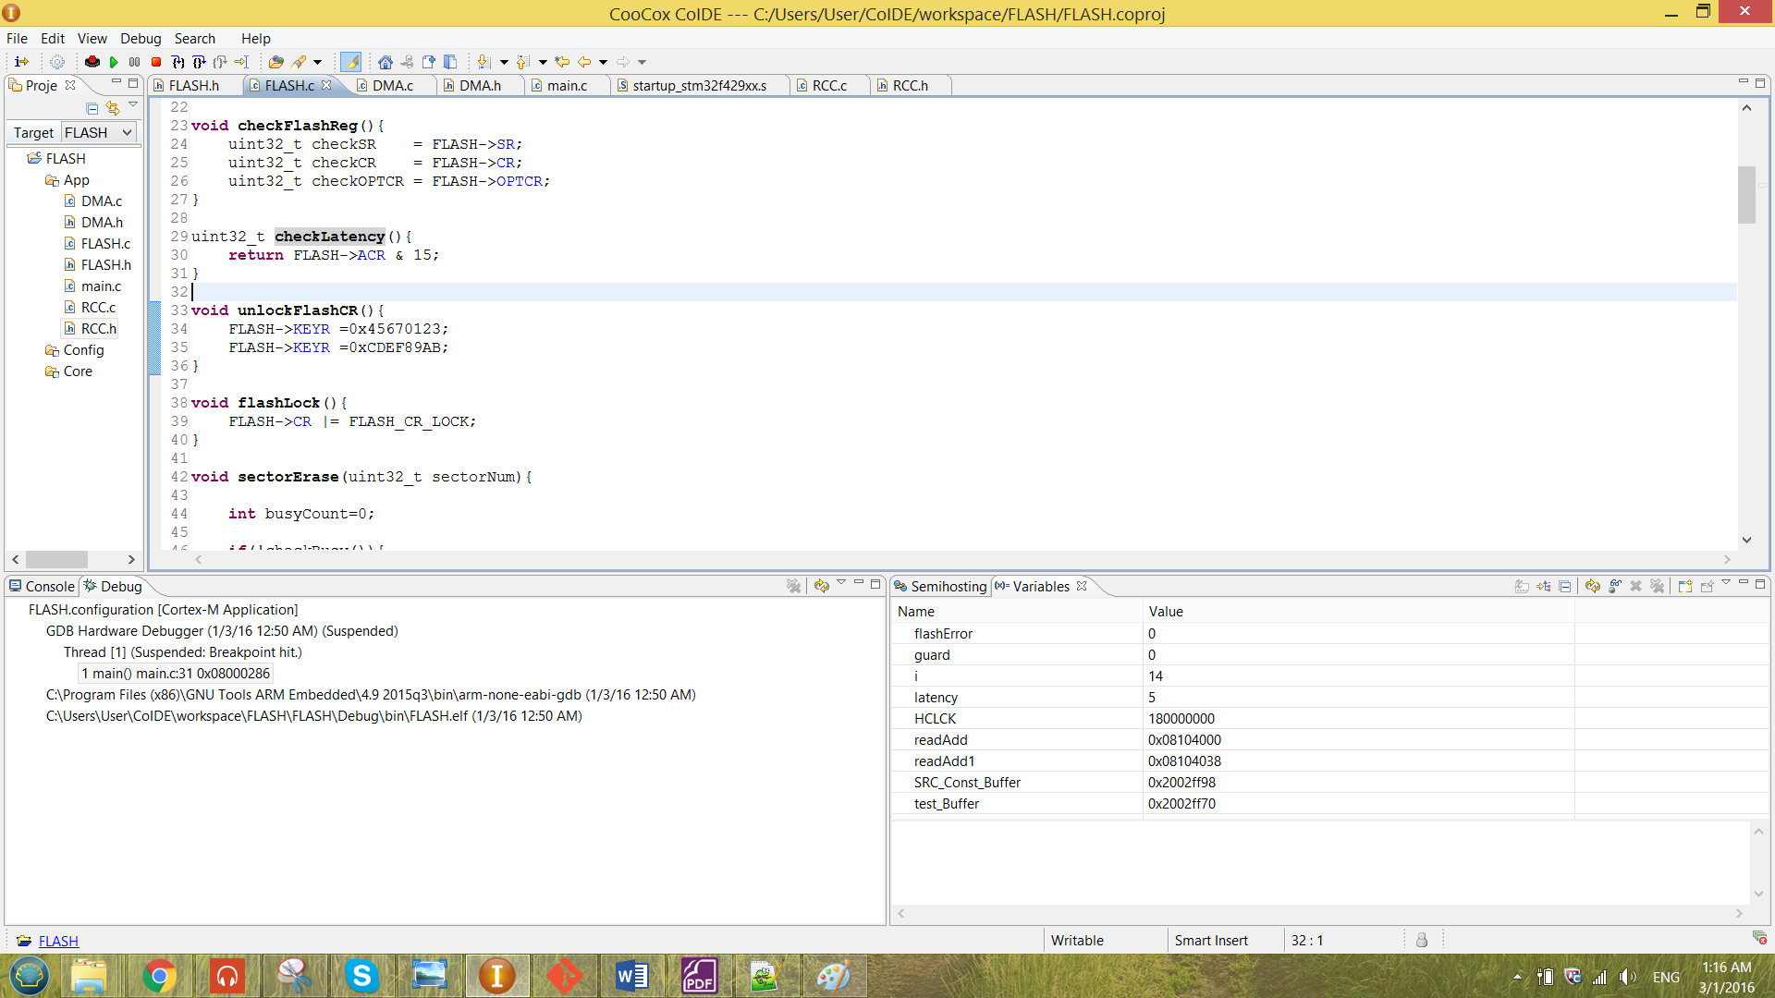

Figure 13 function checkLatency

From the function shown above, it mask the first five bit of the FLASH_ACR which is the LATENCY[3:0] bit. The function is called in the main to determine the number of the wait state. The function been called is as shown below.

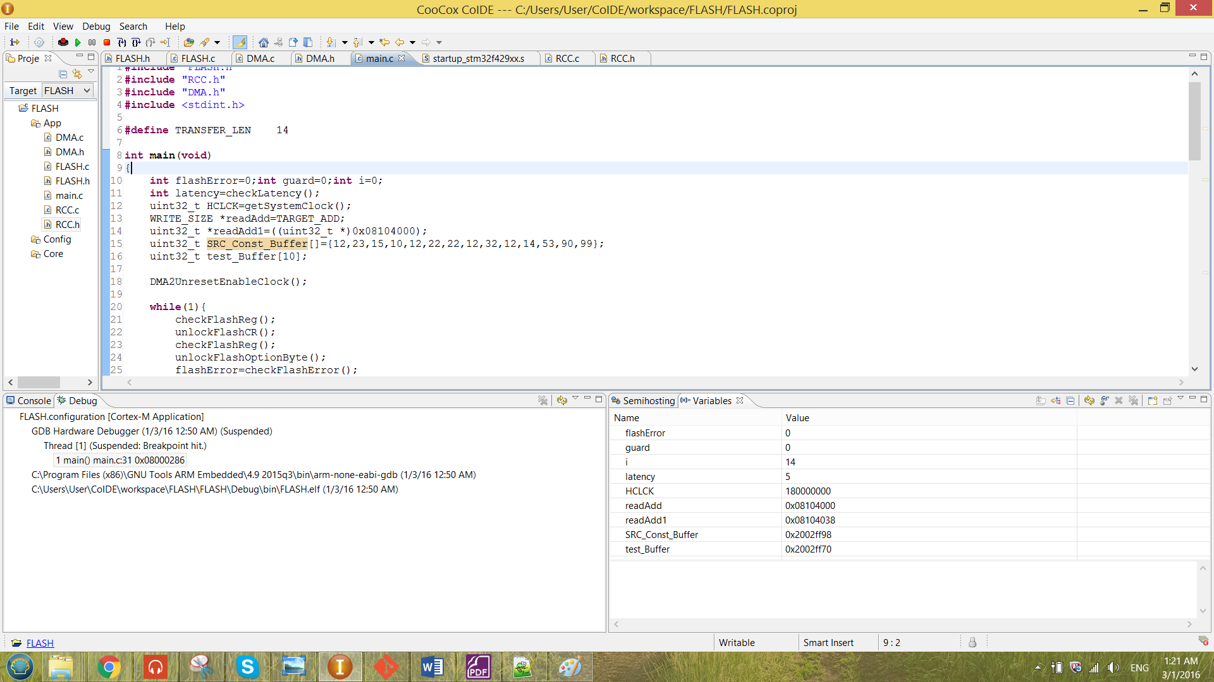

The value of the latency will be stored at latency. The value shows after debugging is also shown in table 3. The latency shown in the table was 5. Thus, by referring to the figure 5. The obtained values for frequency and the latency in table 3 was correct.

To observe whether the data has been successful modified by any operation, a pointer has to be created to point to one of the address that is located in the flash memory. The pointer created is as shown below.

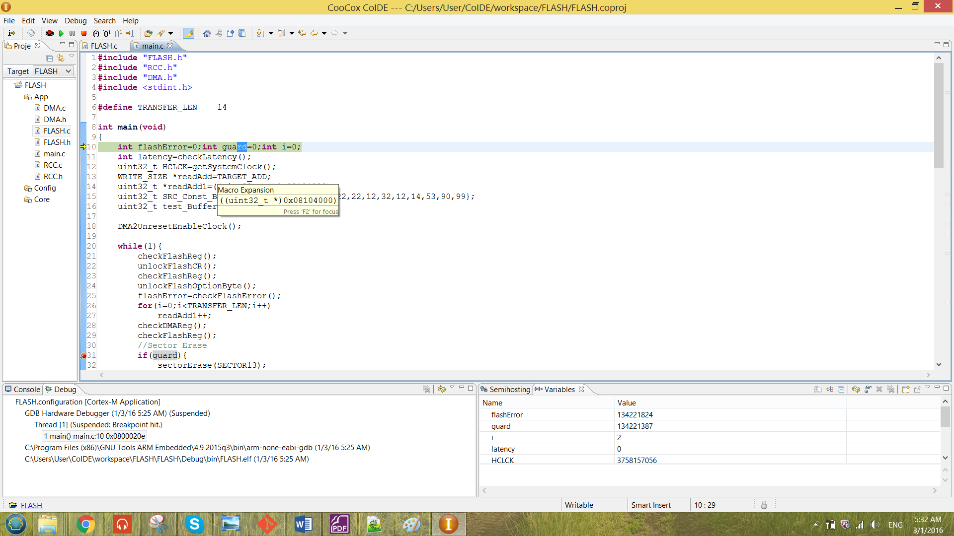

The WRITE_SIZE and the TARGET_ADD are the macro created to simplify the job when configuring the flash memory.

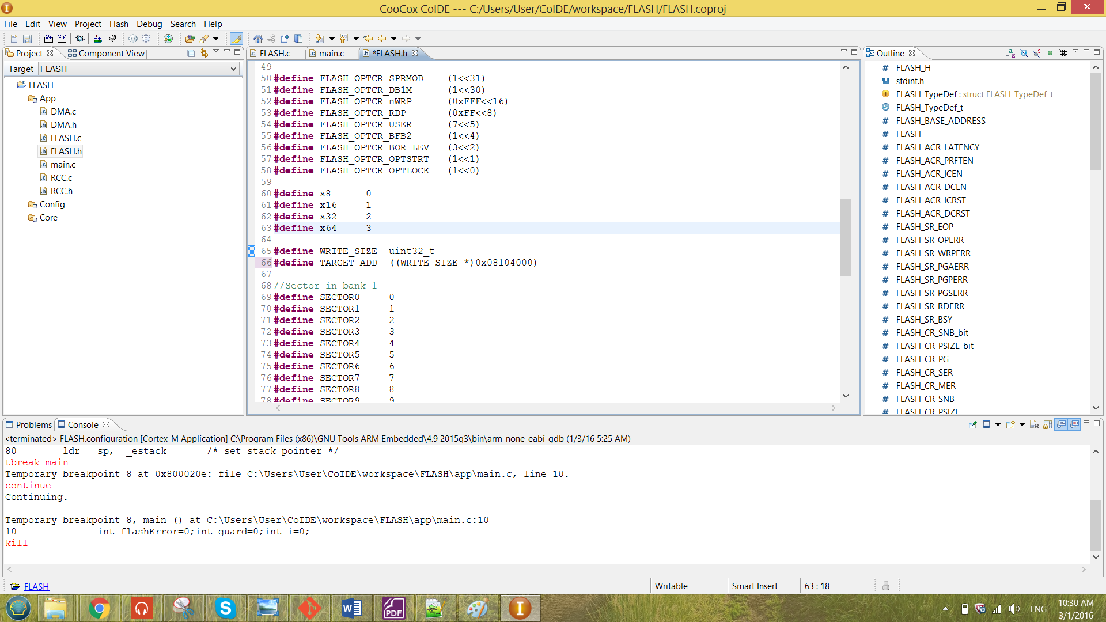

The WRITE_SIZE shows the size going to be written into the flash and the TARGET_ADD is the target address chosen to perform any operation. For the readAdd, the type declared was the type which being written to the flash. The TARGET_ADD also following the same size. The result after debug is as shown below.

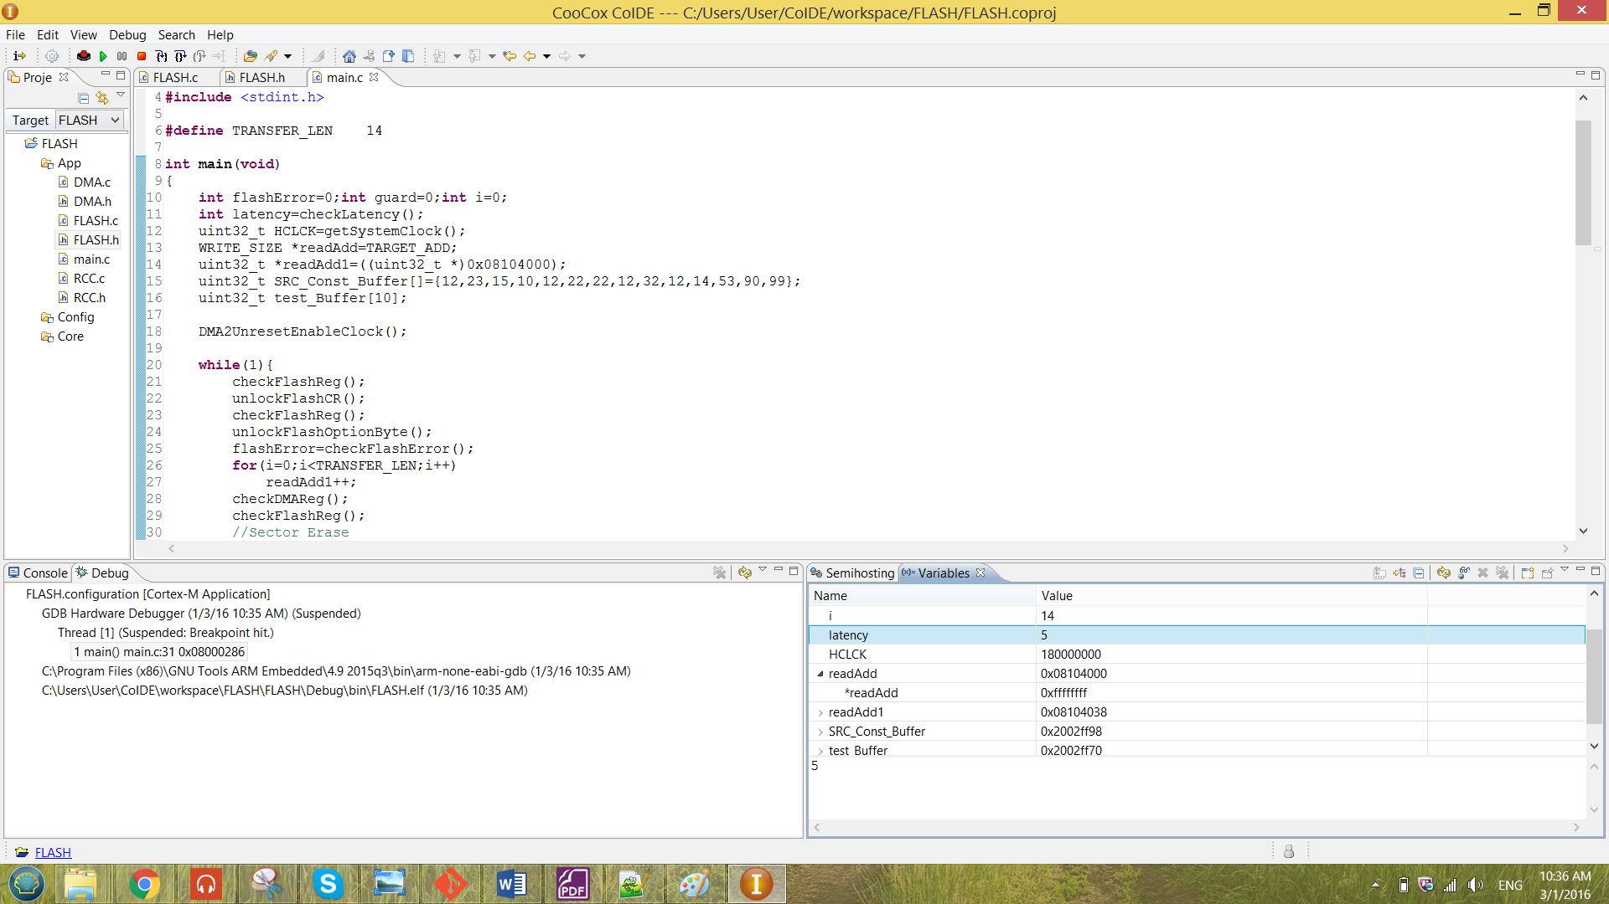

The first line shows the address pointed by the pointer while the second line shows the value inside the pointed address.

2.3 Erase Operation

In this section will discuss how the sector erase and the bank erase to be successfully been configured. There are unable to erase sector 0, bank 1 and to perform Mass erase for this program. That is because the current program written is stored in the sector 0 in the bank 1. If sector 0 is being erased, the program will give an error as shown below.

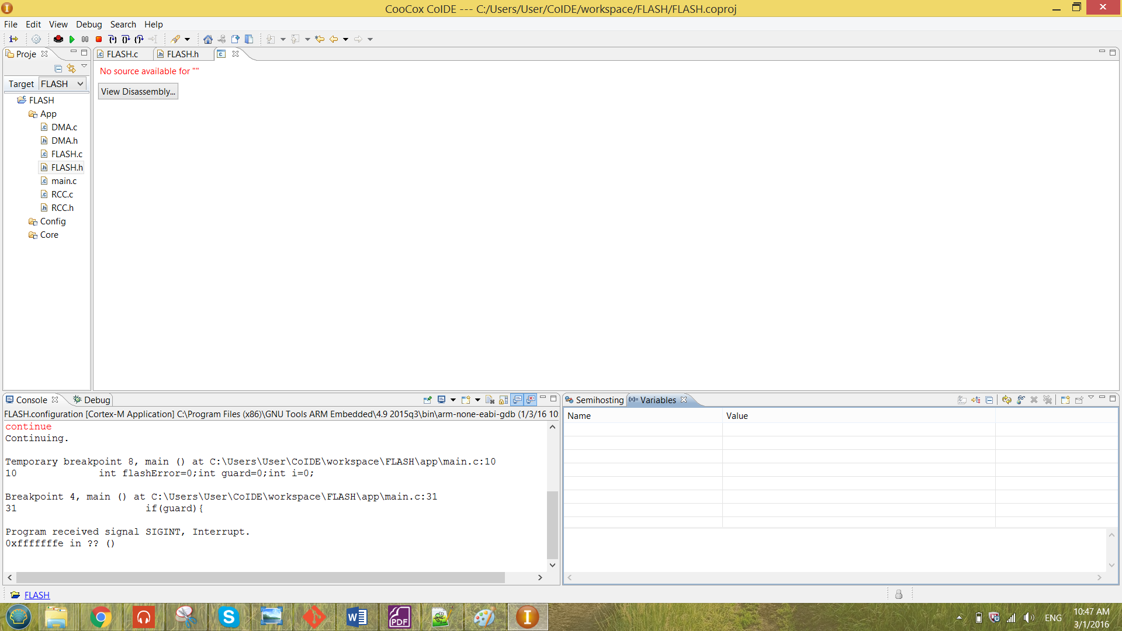

Figure 14 error message shown when erasing sector0/bank1/Mass erase

In the following section, Sector erase will choose to erase sector 13 and the bank erase will choose to erase the bank 2.

**i) Sector Erase**

The sector erase function is as shown below.

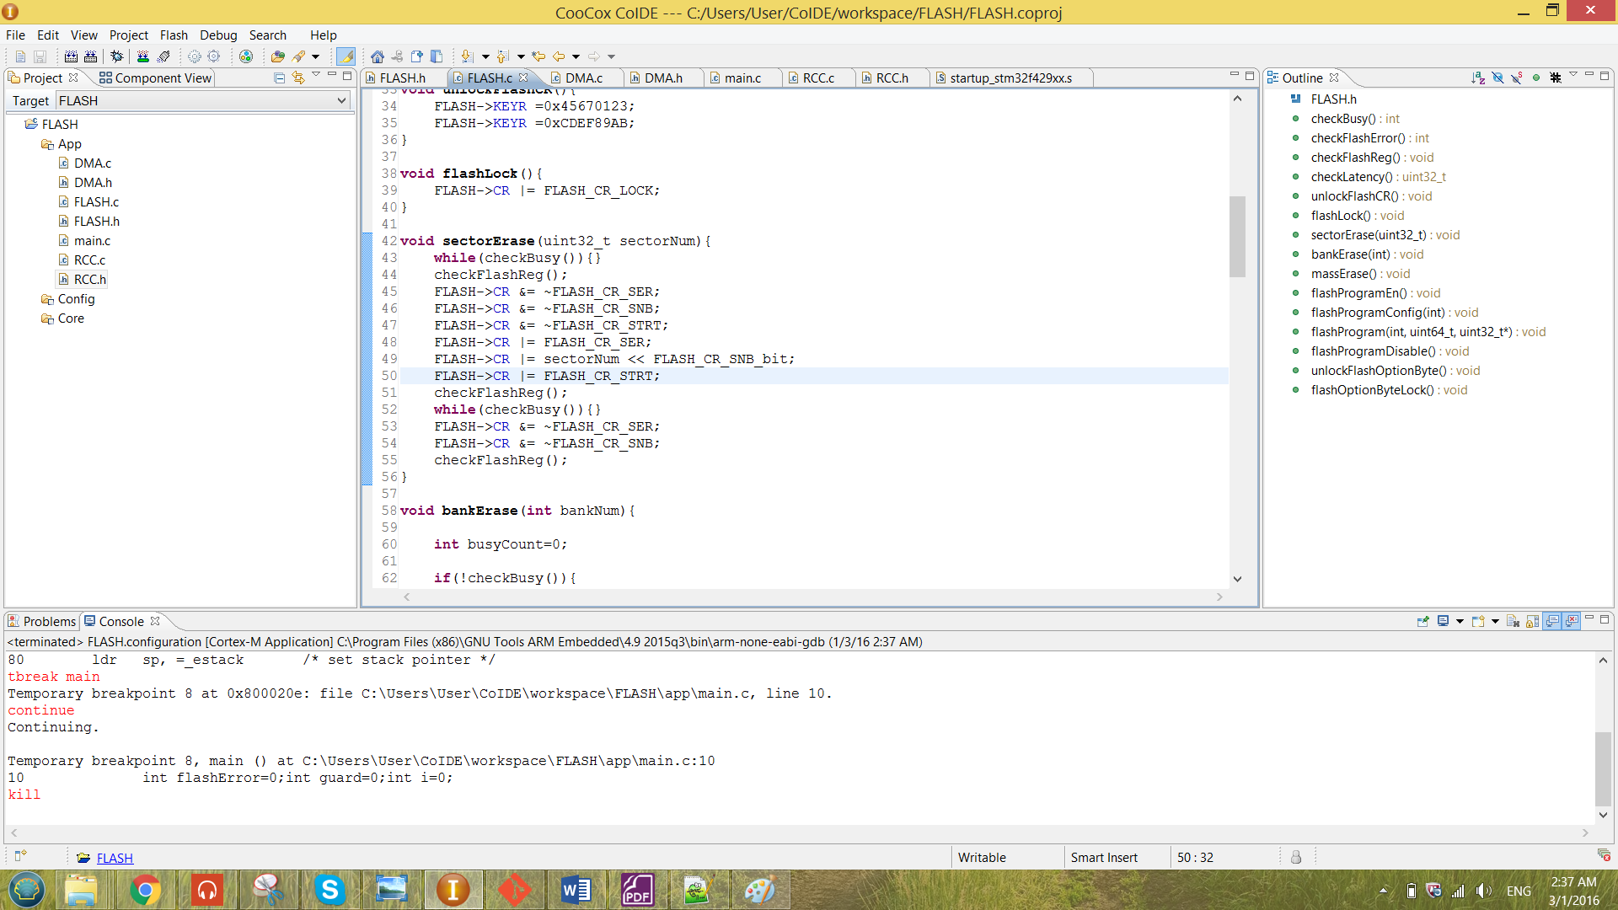

Figure 15 function sector erase

From the Figure 14 above, the function is passing in the sector number of the Flash Memory. At the beginning of the function, the while loop is to check whether there are any flash memory operation ongoing. The function checkBusy is as shown below.

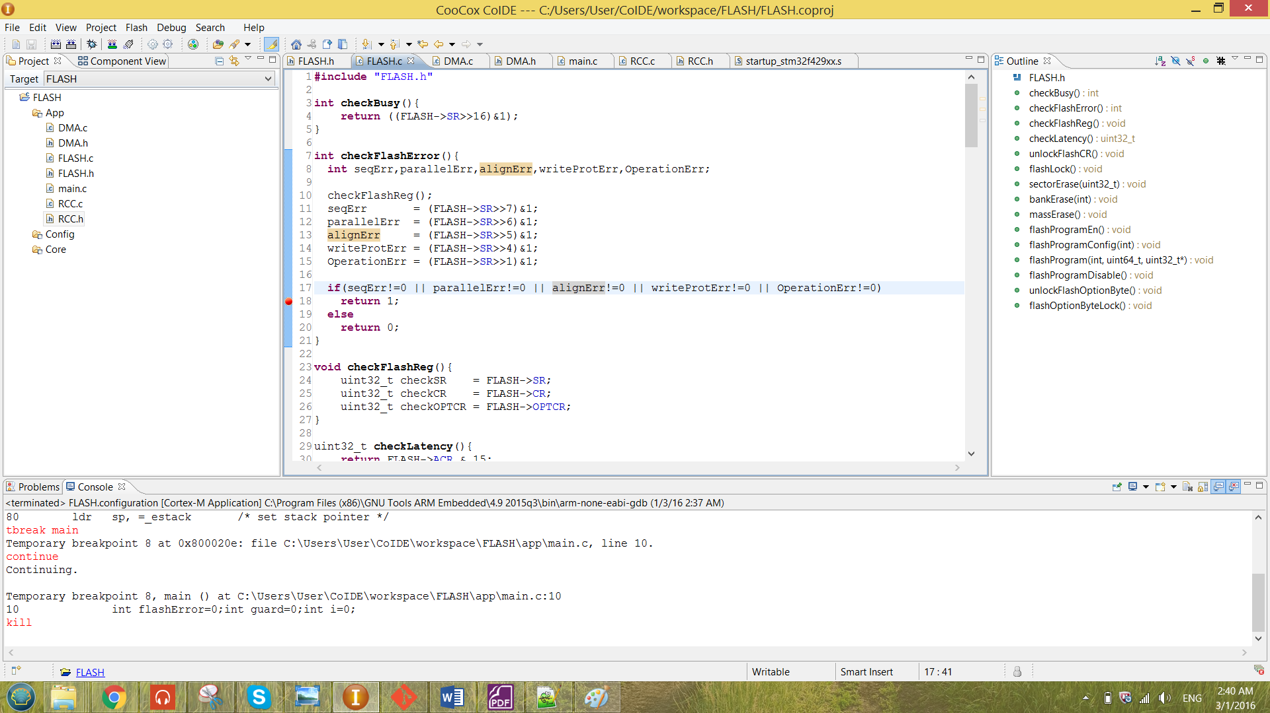

Figure 16 function checkBusy

The return value for the checkBusy function is following the BSY bit in the SR register. So at the while loop shown in Figure 14, the system will keep looping if the function return ‘1’ until the BSY bit has returning back to ‘0’. The while loop also has been used in the end of the function to ensure the system is ready to perform the next flash operation.

From the figure 14, the checkFlashReg function has been called again to check the data before and after configure of the flash registers. The check function at line 44 of the figure 14 is giving the result as below.

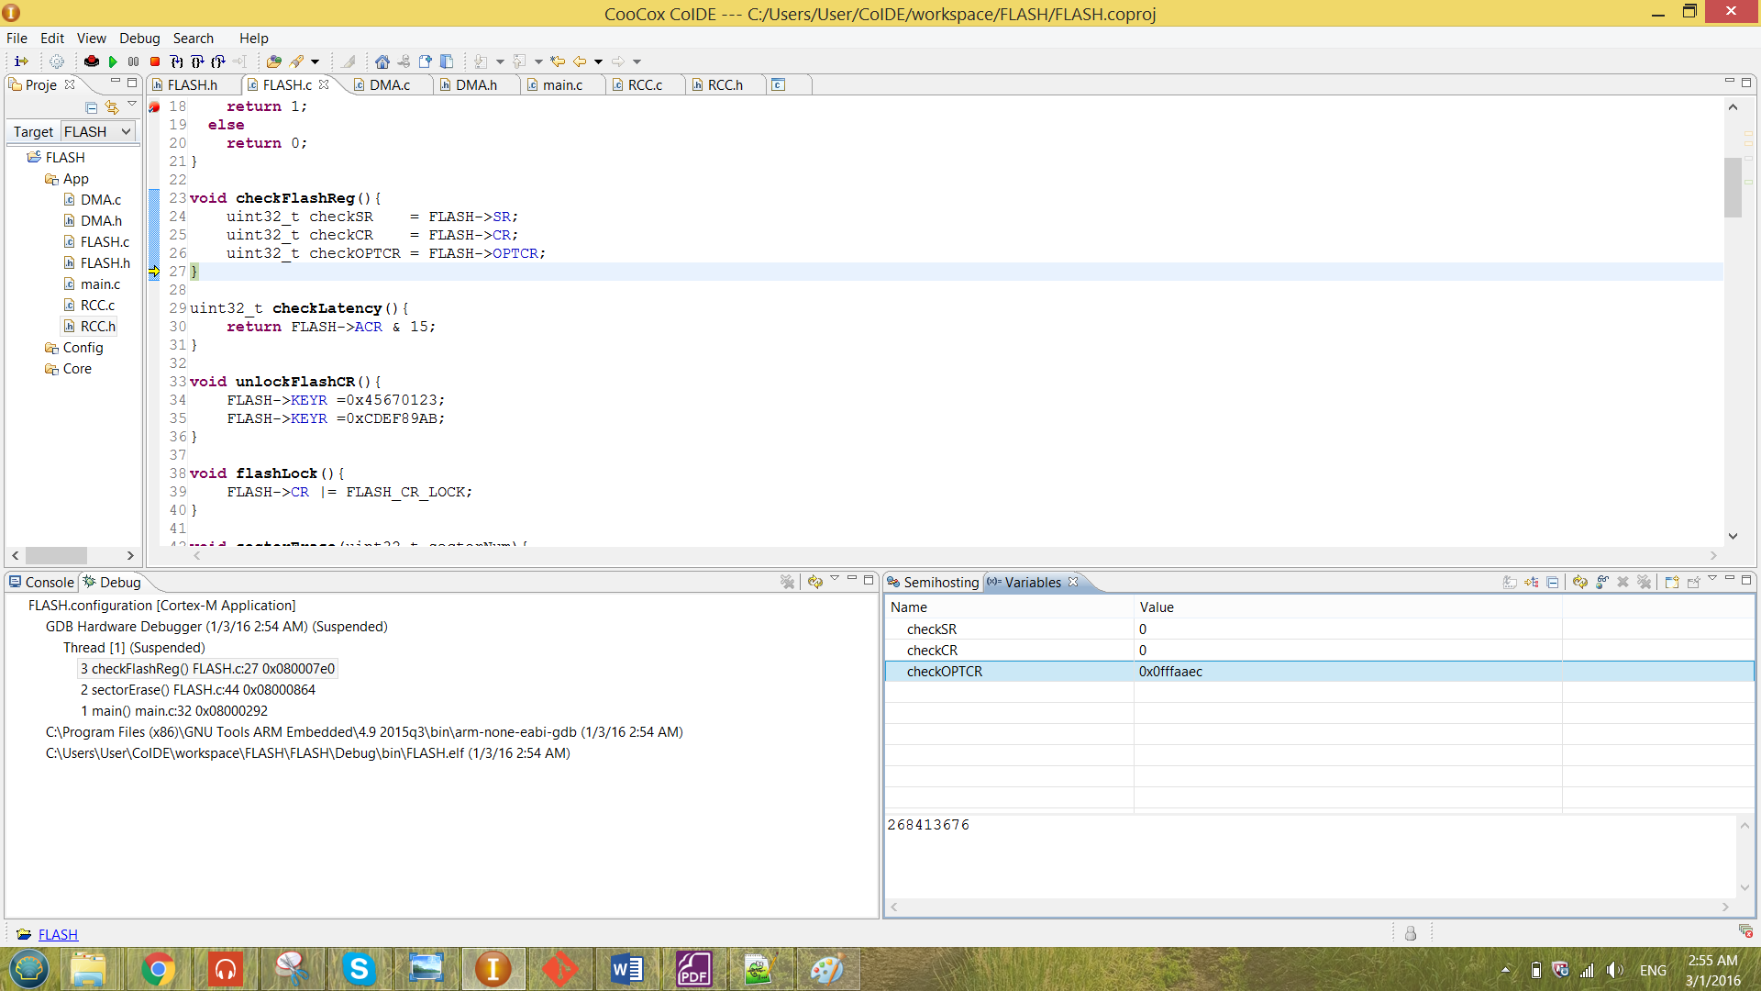

From the result observed above, the initial value for both SR and CR are ‘0’. The result observed after the configuration is as shown below.( the check function at line 51.)

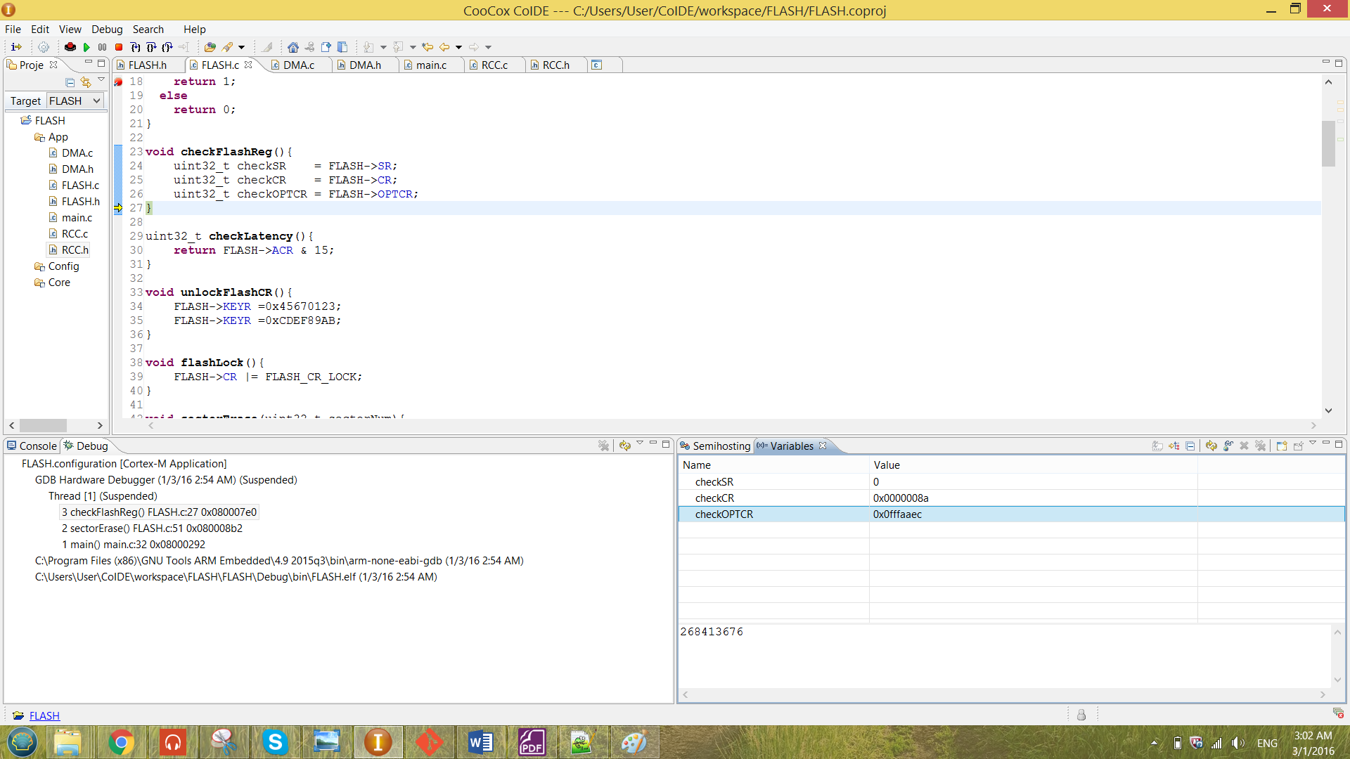

From the result obtained above, the value has been successfully configured into the CR register. The configuration are the SER and the STRT bit in CR has been set. The value 10001 has been stored to the SNB[4:0] bit to choose the sector 13 to be erased.

After the configuration, BSY bit has been checked. When it is not busy, it will jump out of the loop at the same time the STRT bit in the CR register has been set to ‘0’ by the software. All the other bits of the register has been reset so that it is ready to perform the next flash operation.

The function called in the main is as shown in the figure below.

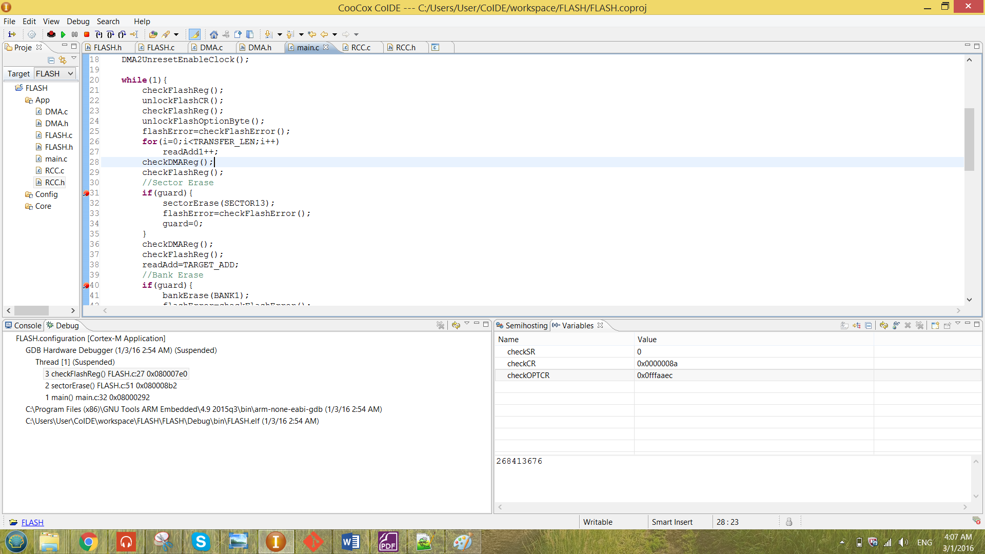

Figure 17 sectorErase function called in the main

At line 32, the macro “SECTOR13” has been passed in to the function. The macros created for each of the SECTOR is as shown below.

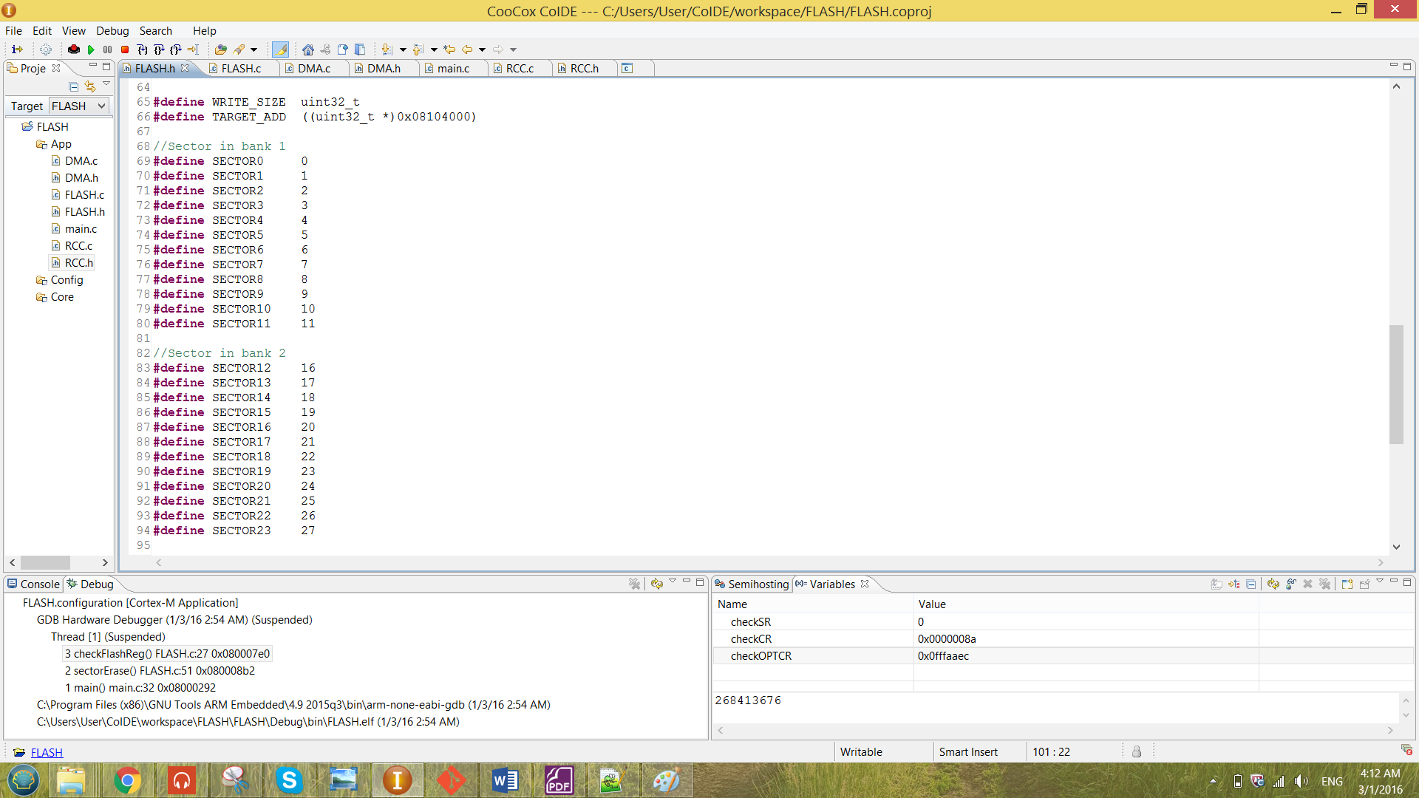

Figure 18 sector macros created for both bank 1 and bank 2

Looking back to the Figure 16, the guard technique has been used. Which is the ‘if’ statement before performing the sectorErase. The value of the guard has been initialize to be zero so that it will not perform any operation unless the guard value has been modified manually. In every operation of the program, a break point has been placed at the ‘if’ statement. So if that particular operation has been chosen to perform, the guard has to be change manually to ‘1’. The modifying value of the guard is as shown below.

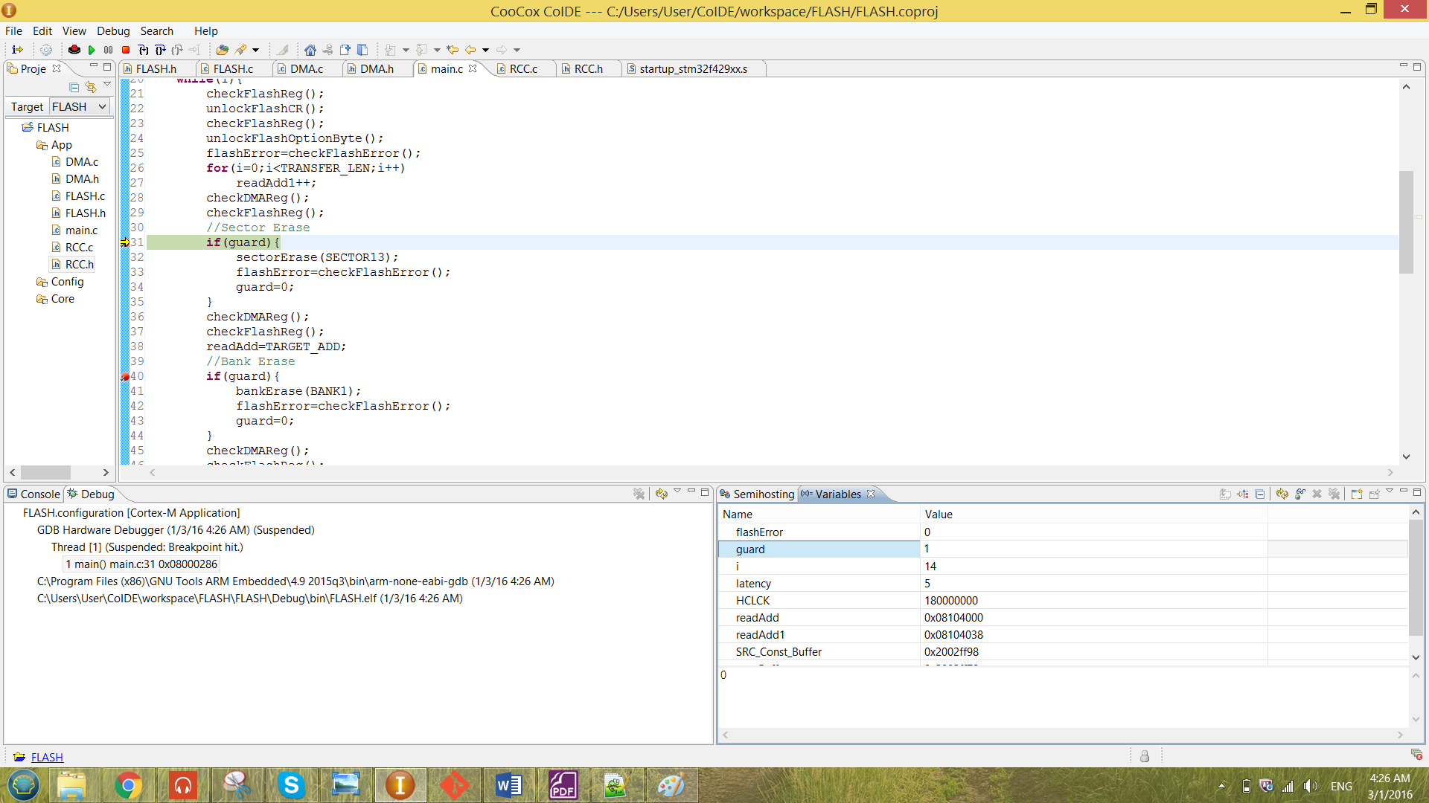

From the result shown in the figure above, the guard value has been modified to ‘1’ manually to perform the particular operation.

The sector erase operation has been illustrate by using the readAdd pointer that has been discussed in the previous section. Initially some value has been program to the address 0x08104000. The initial value has been shown below.

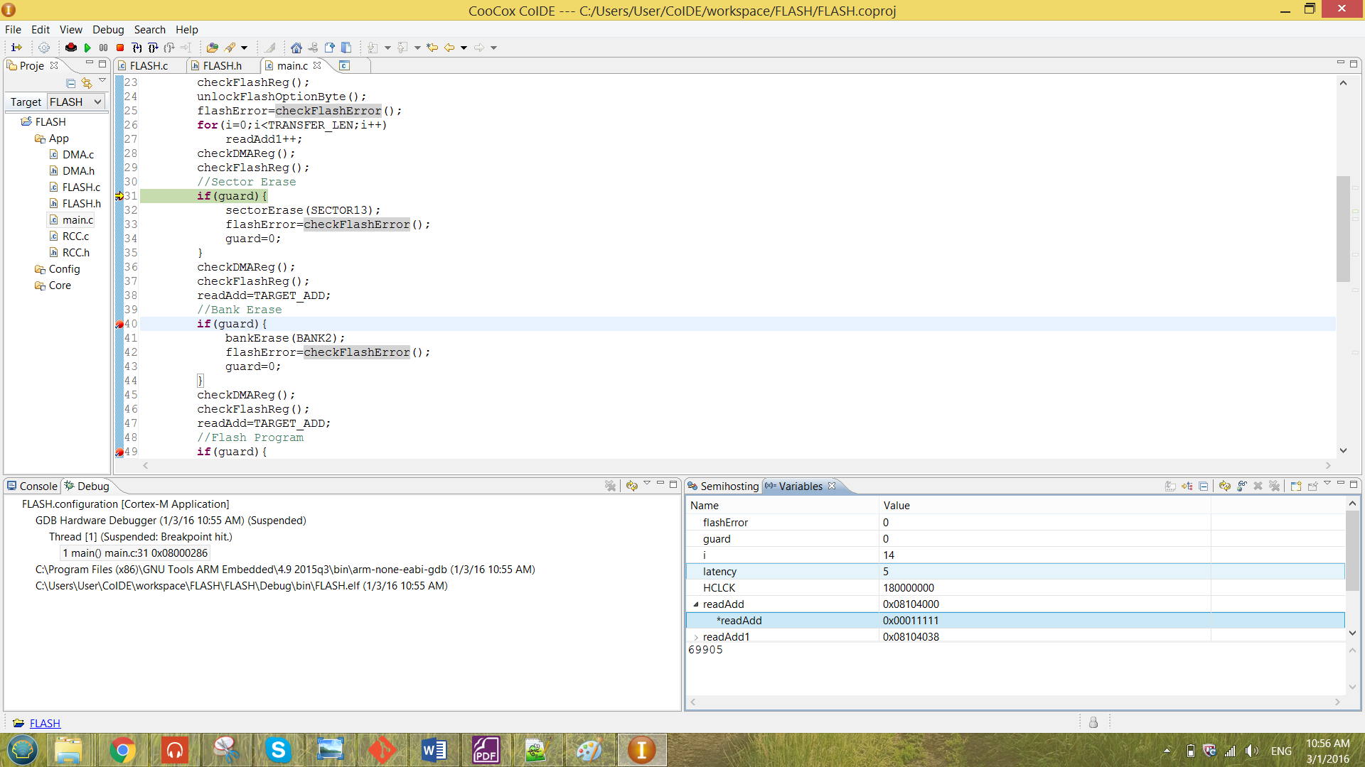

When the program reach the breakpoint in figure 17, the value of the guard has been modified manually to enable performing sector erase. After it run though the code in figure 17 without any error, the system has to be reset only the erased value can be observed. The value after been erased is as shown below.

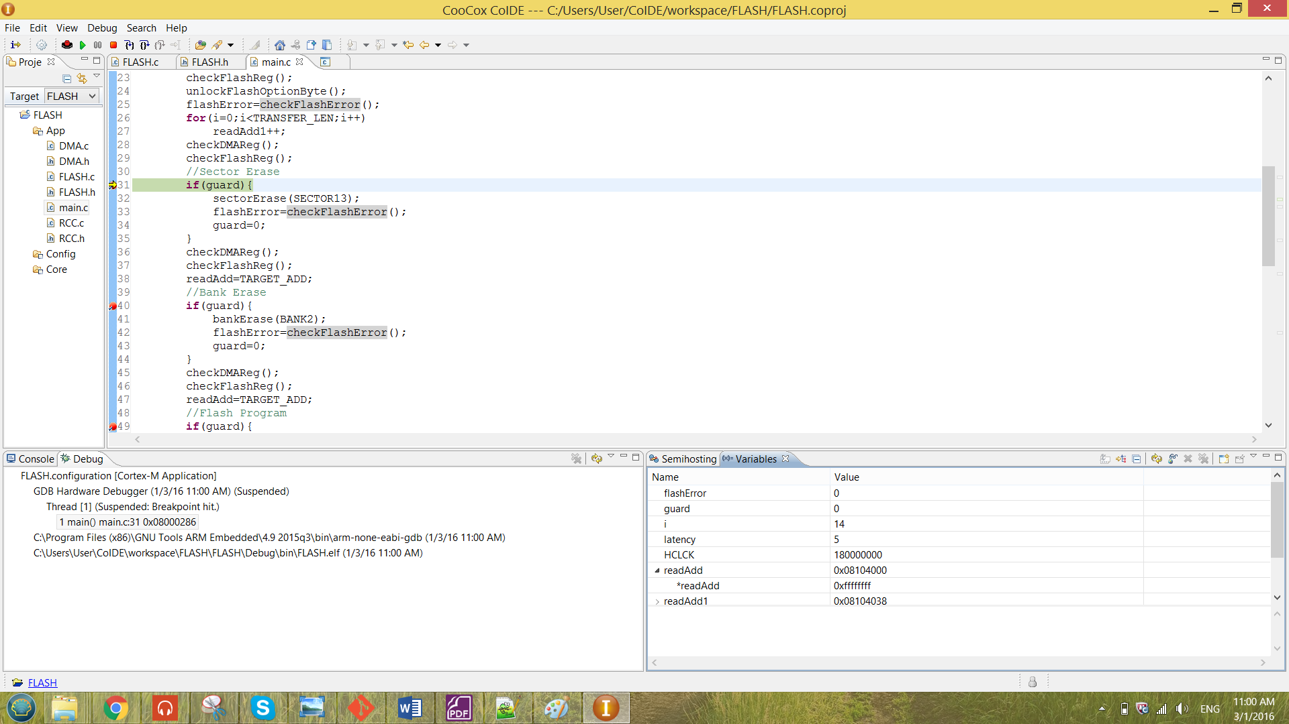

From the result observed above, the result has been successfully been erased as the value of *readAdd has become 0xffffffff.

**ii) Bank Erase**

The bank erase function is as shown below.

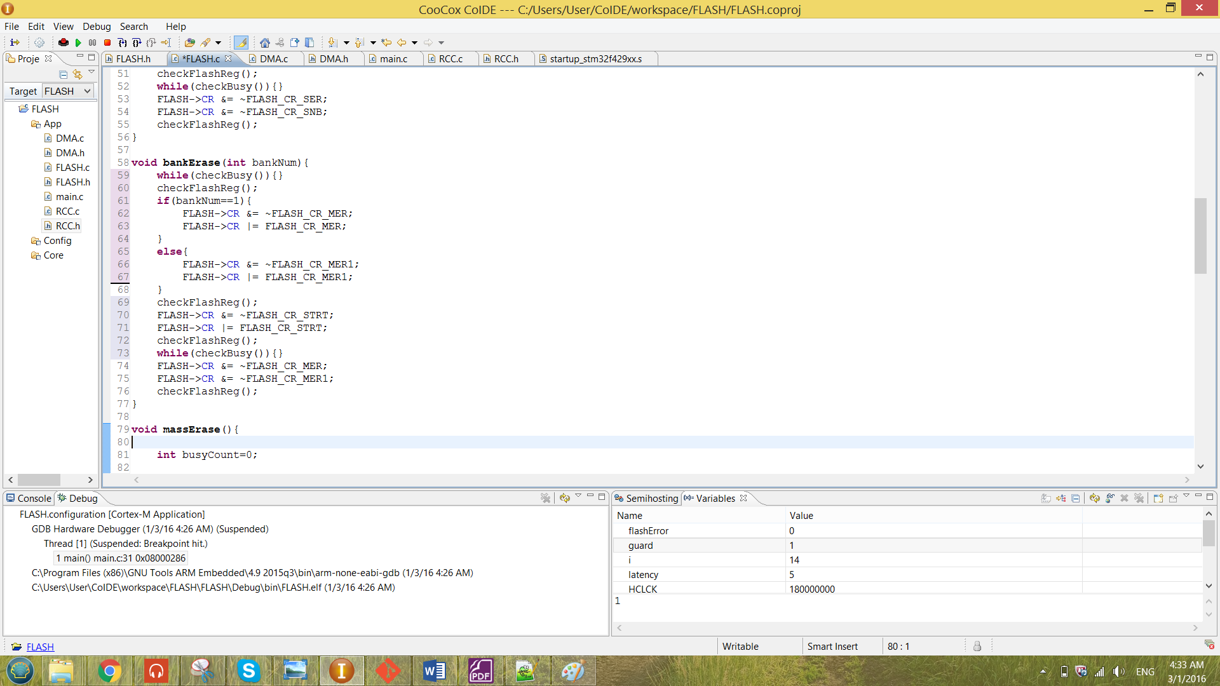

Figure 19 function bankErase

From the Figure 18 above, the bankErase function is passing in the bank number that to be erase. The bankErase operation is most likely the same as the operation of the sectorErase, the only difference is that the enabling bit of the CR register has been changed to MER or MER rather than SER for the sector erase.

The choosing of MER and MER1 is decide on whether the bankNum is ‘1’ or ‘2’. Value ‘1’ stands for erasing bank one and value ‘2’ stands for erasing bank two. The flash register has been checked by the checkFlashReg function. The value before and after the configuration is as shown below.

**The CR register before configuration (line 60):**

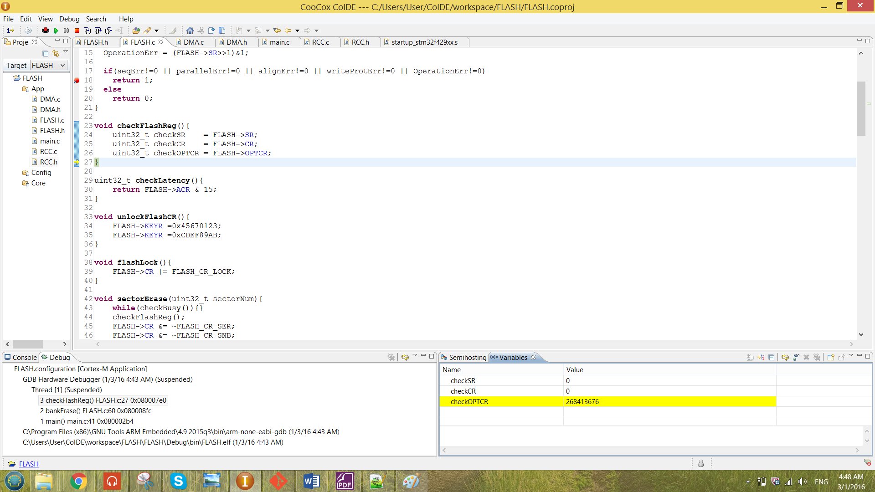

**The CR register after configuration (line 72):**

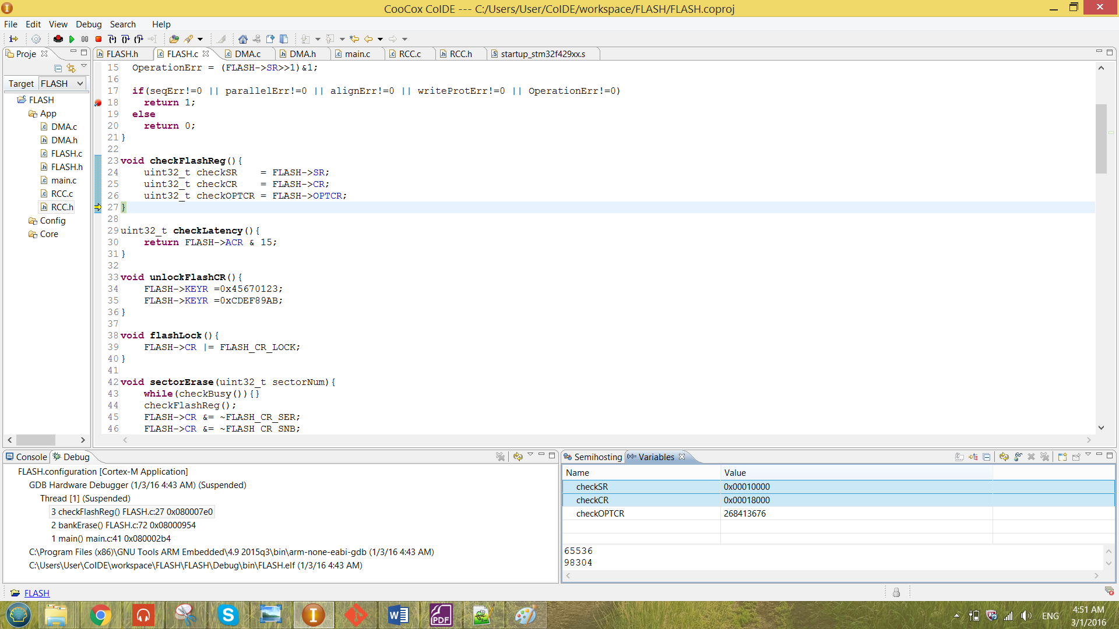

For the result obtained above, it is erasing the bank 2 of the flash memory. Note that Bank 1 is unable to be erased, the reason has already discussed in the previous chapter.

For the result obtained for the after configuration, the BSY bit of the SR register has been set. This will not cause any problem to the program, that is because the while loop mentioned previously can be solve the problem.

The bank erase will take more time than the sector erase, because for the bank erase it need time to erase all sector in the bank. Each bank consist of 12 sectors, so the bank erase will take 12 times slower than the sector erase.

The function called in the main is as shown in the figure below.

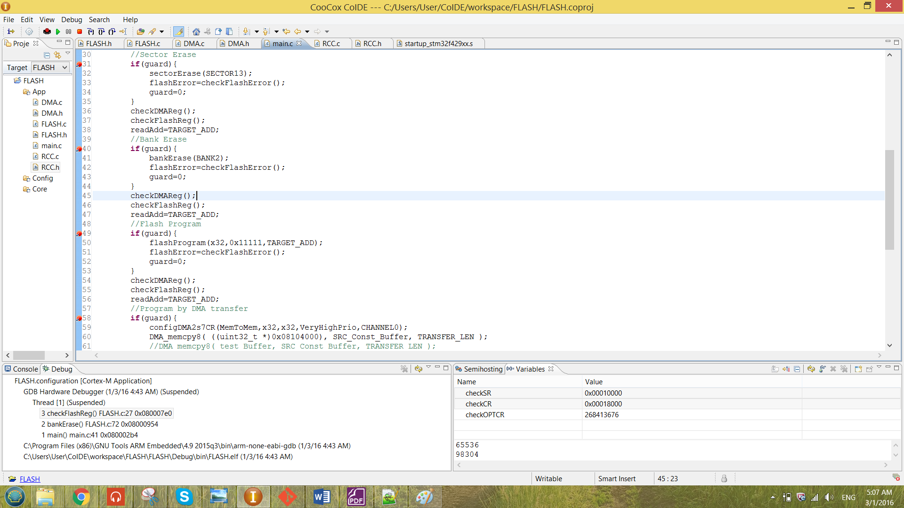

Figure 20 bankErase function called in the main

At line 32, the macro “BANK2” has been passed in to the function. The macros created for each bank is as shown below.

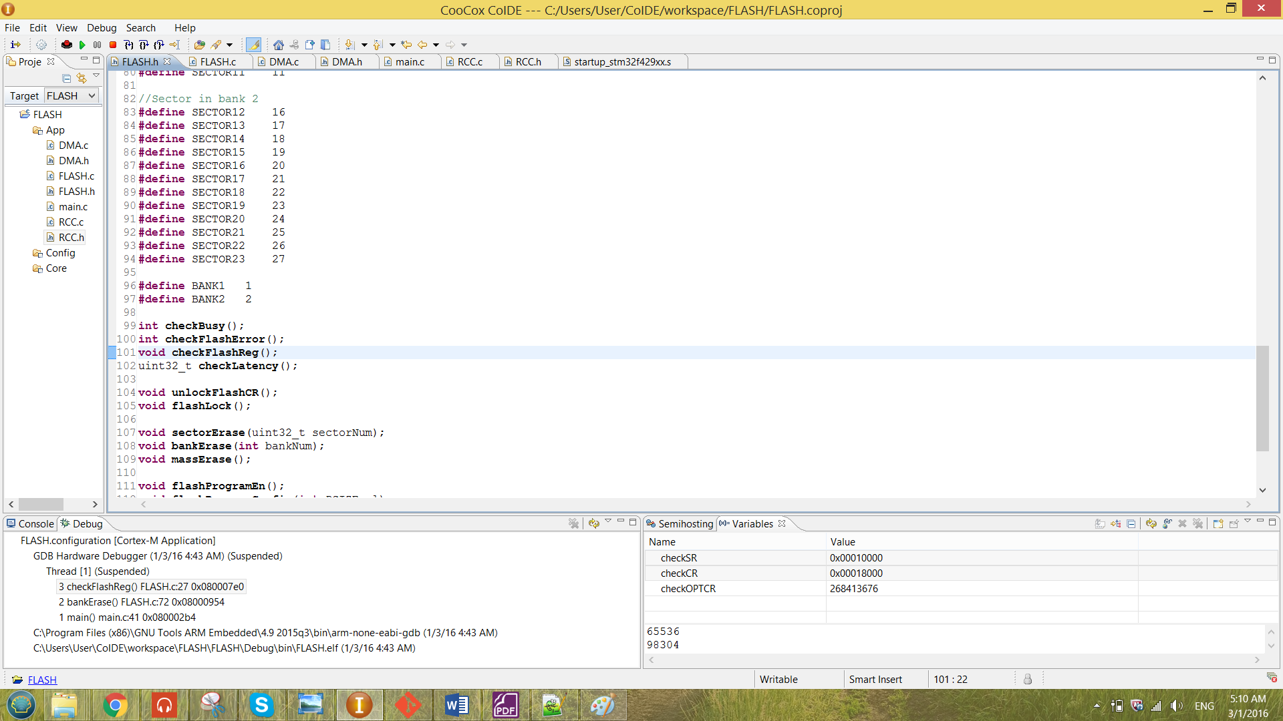

The guard technique has also been used for the bankErase operation. The guard will set to ‘1’ when bankErase operation is needed to be performed.

The bank erase operation has been illustrate by using the readAdd pointer that has been discussed in the previous section. The discussion will be similar to the sector erase.

**ii) Mass Erase**

The mass erase operation was unable to be perform because the bank 1 was unable to be erased.

2.3 Program Operation

The flashProgram function is as shown below.

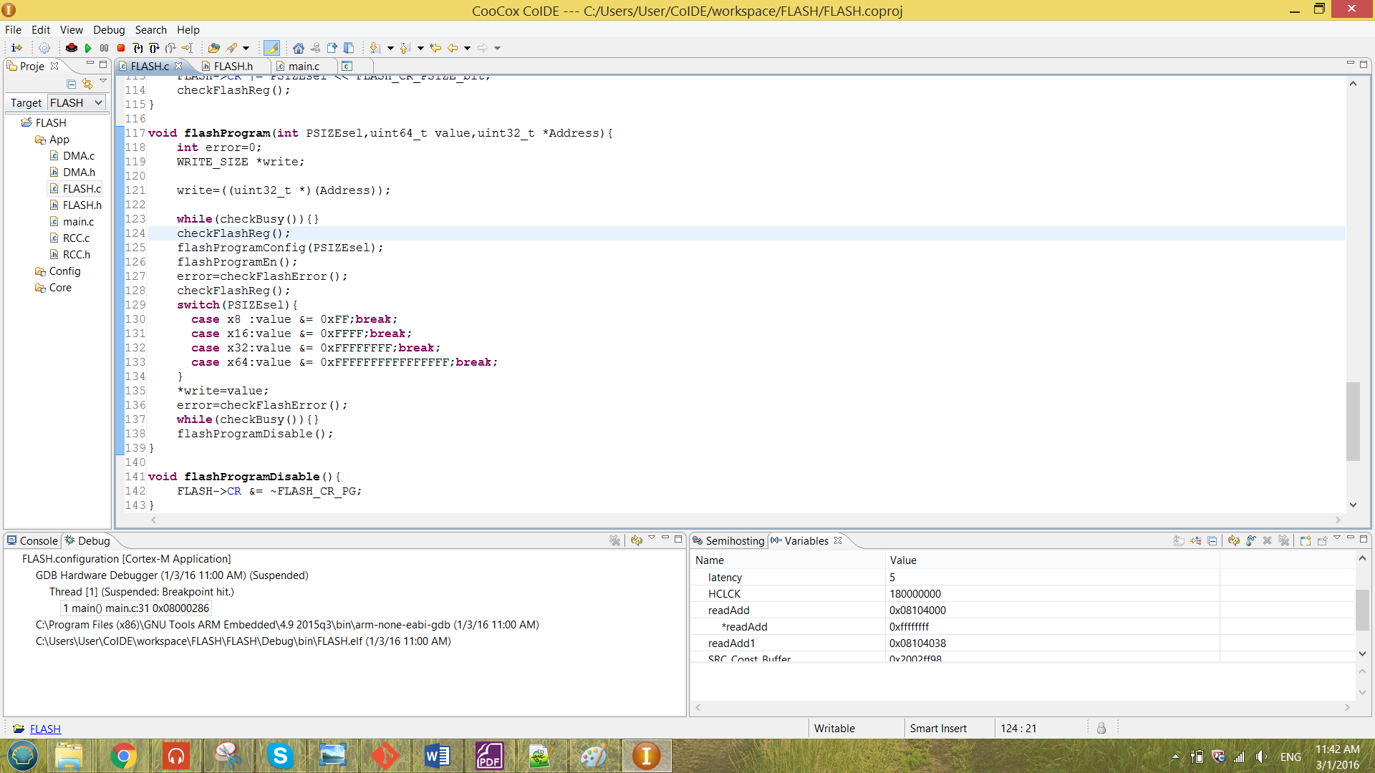

Figure 21 function flashProgram

The function is passing in three element which are the PSIZE select, the value to program and the address selected to program. For each PSIZE has been selected, the function will mask the value (with size x64) to the size been selected.

From the Figure 21 above, a pointer has been created for the programming purposes. The pointer has been pointed to the address that has to be program. The pointer will only pointed to the value when all the configuration has been done.

There are also error checking function inside the flashProgram function. The error checking function is the checkFlashError function. The function is as shown below.

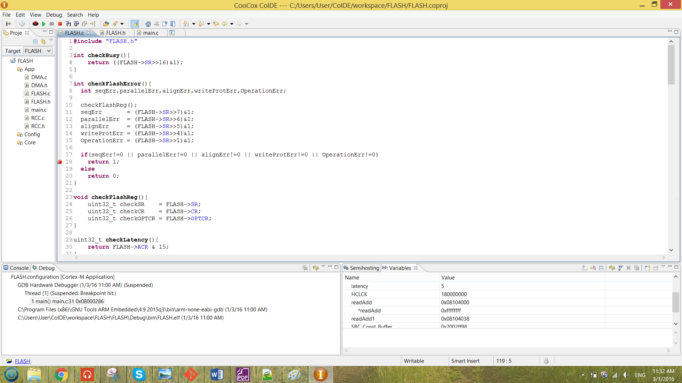

Figure 22 function checkFlashError

When there are any error sense in the SR register, the system will be caught at the breakpoint at line 18 in Figure 22.

The flashProgramConfig and the flashProgramEn function also has been included into the function checkFlashError. These function have been shown as below.

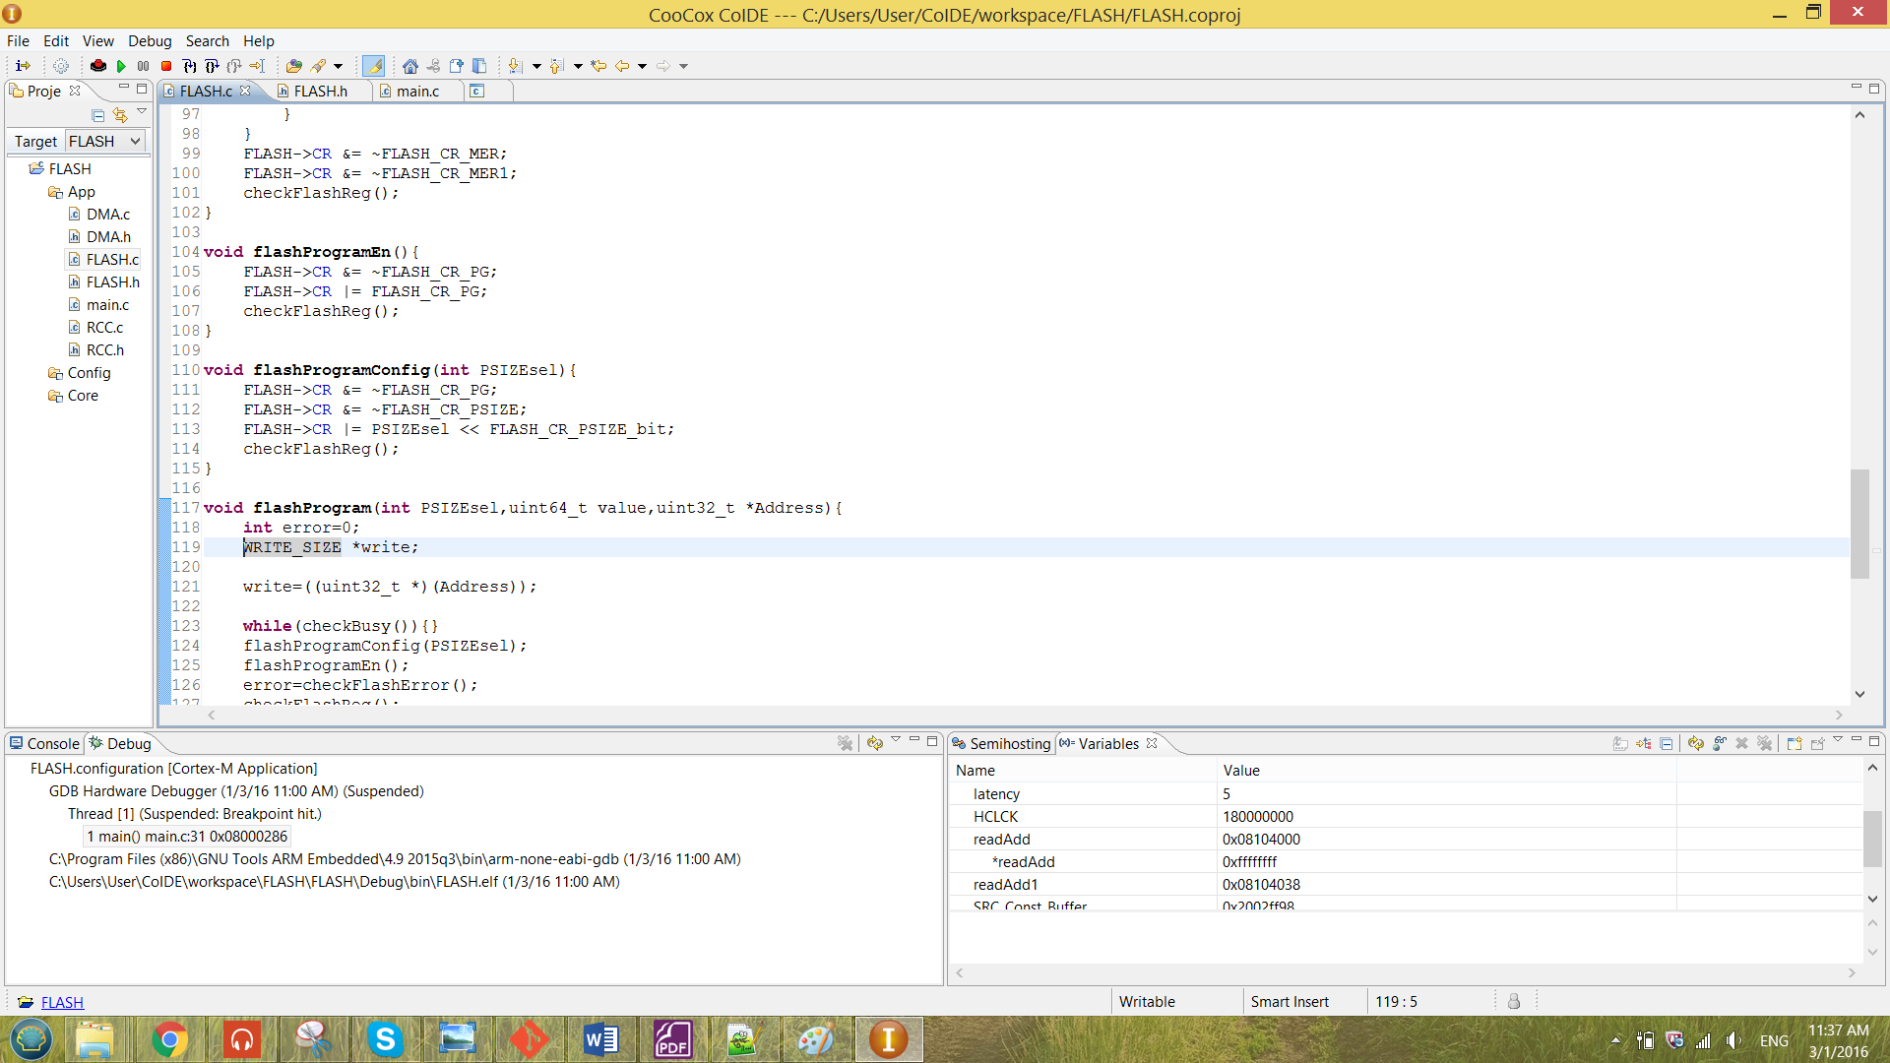

Figure 23 function flashProgramEn and flashProgramConfog

The function flashProgramConfig is to pass in the value of the PSIZE and config the value of the PSIZE to the CR register of the flash. In this function, the programming bit (PG) has been ensured to be disabled.

After the PSIZE has been configured in to the CR, the flashProgramEn only been called to enable the PG bit of the CR to start programming. The changes of the register alue has been debugged as shown below.

**The CR register before configuration (line 124):**

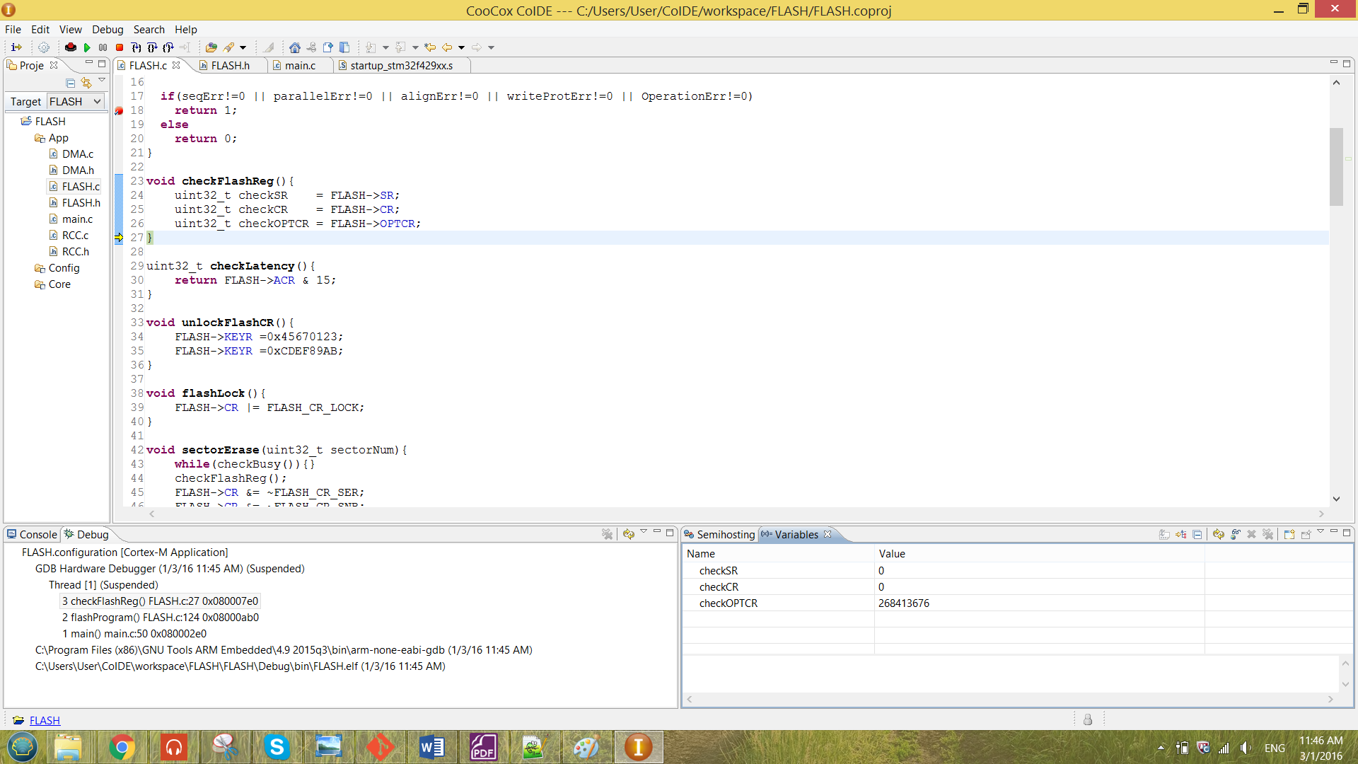

**The CR register after configuration (line 128):**

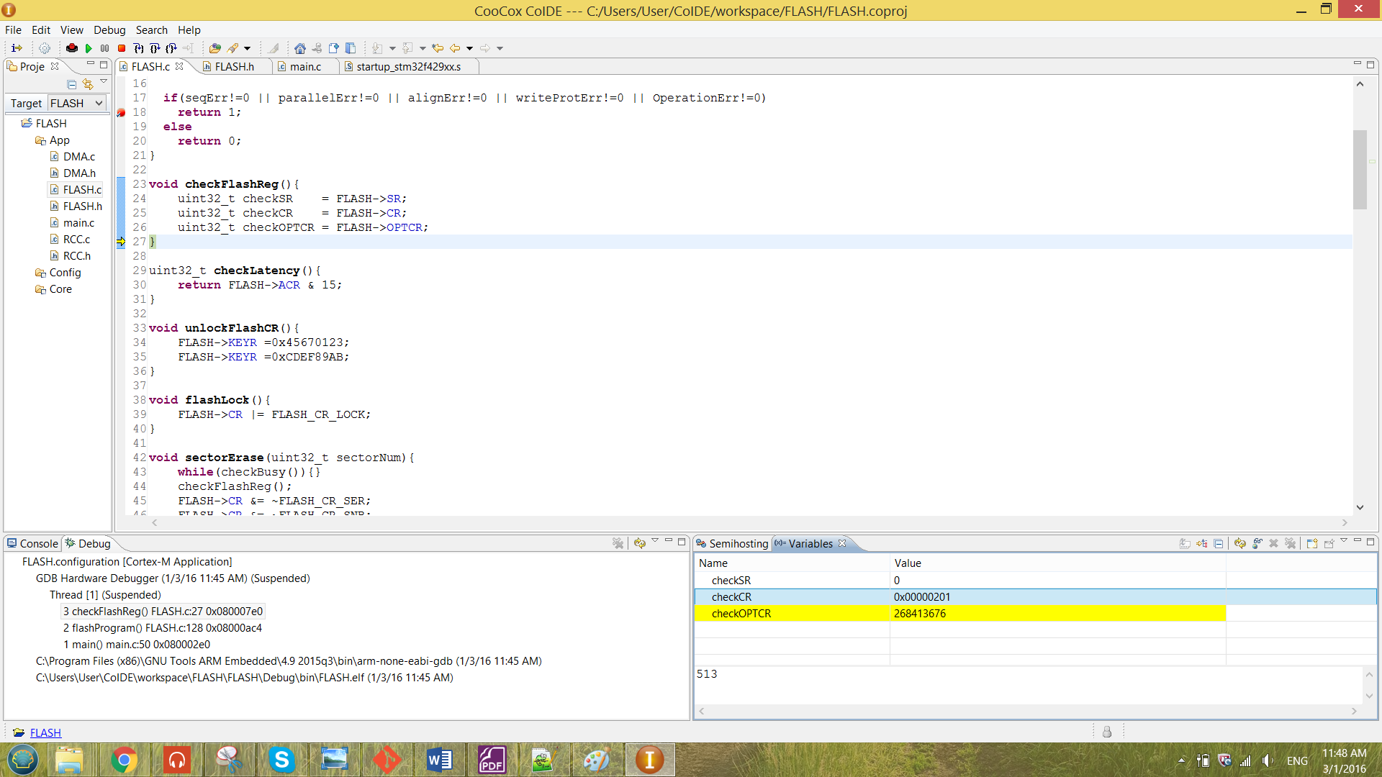

From the result shown above, the correct value has been configured into the CR register. Also the system does not caught by the breakpoint in figure 22. These shows that there are no error while configuring the CR.

After the PG bit has been enabled the program value masked has been pointed by the write pointer and has been dereferenced. If there are any error sense by the error checking function and the system is not busy, the value is now successfully programmed into the flash memory address.

The function called in the main is as shown in the figure below.

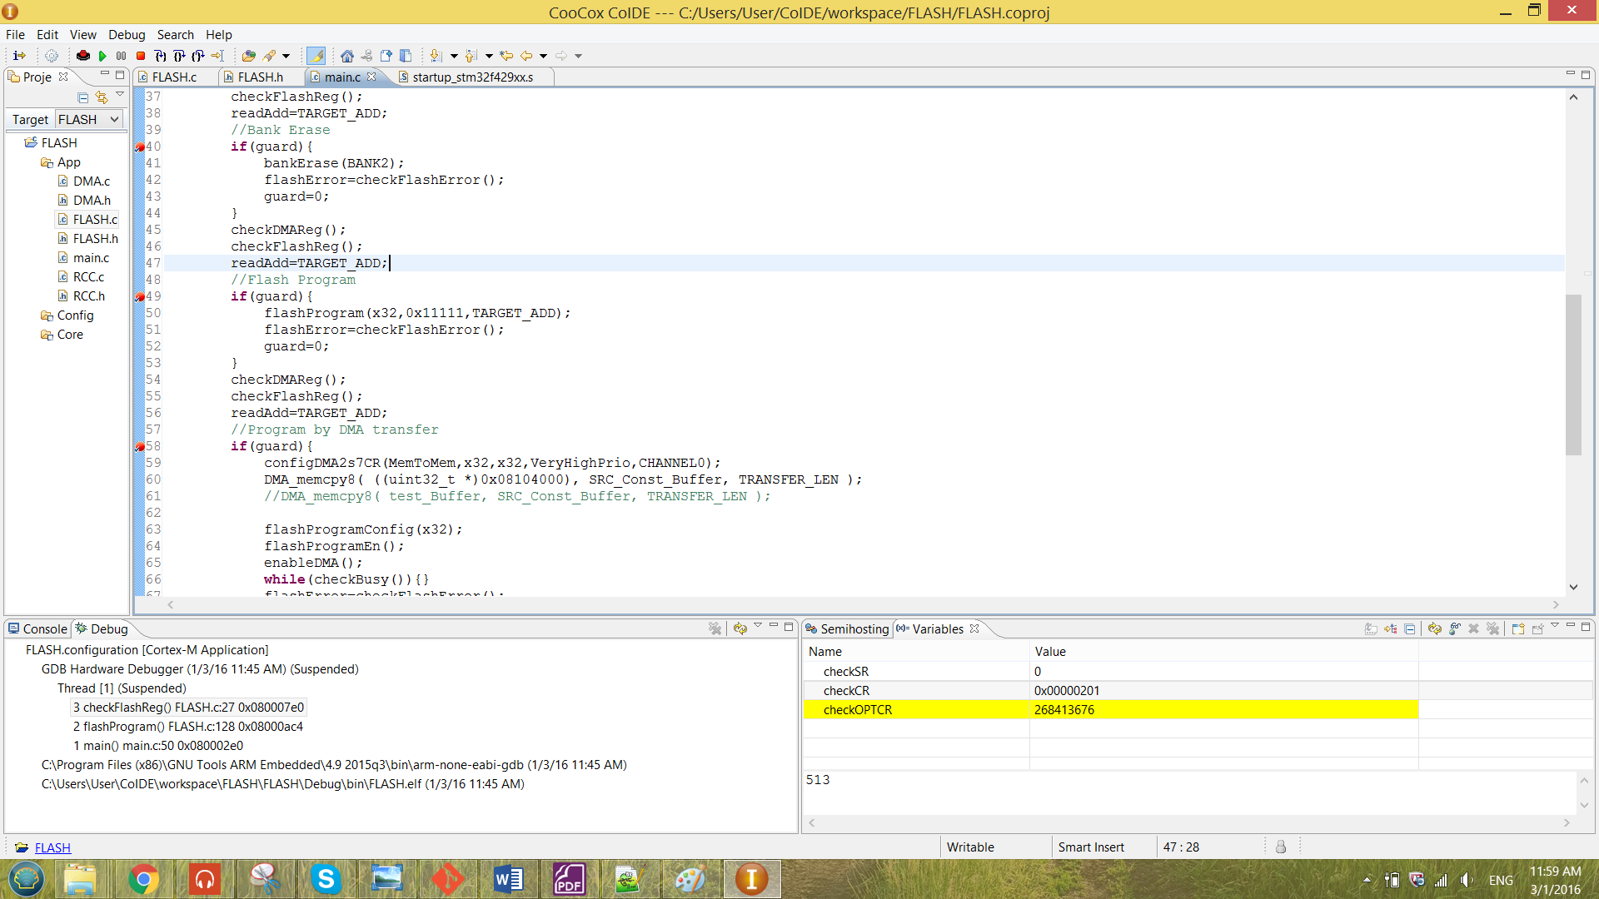

Figure 24 flashProgram function called in the main

Again, the flashProgram are using the same guard technique that is already discussed in the previous part.

The program operation has been illustrate by using the readAdd pointer that has been discussed in the previous section. Initially the selected address 0x08104000 was a empty address (0xffffffff). The initial value has been shown below.



When the program reach the breakpoint in figure 24, the value of the guard has been modified manually to enable performing flashProgram. After it run though the code in figure 24 without any error, the system has to be reset only the programed value can be observed. The value after been erased is as shown below.



From the result observed above, the result has been successfully been programed as the value of *readAdd has become 0x00011111.

The flashProgram function has been tested in different number of PSIZE. For a different PSIZE number chosen, the WRITE_SIZE that mentioned previously has to change according to the PSIZE. And the PSIZE number the input to the flashProgram function also has to change accordingly. For example, the configuration of the flashProgram has been changed as below and the macro WRITE_SIZE has been changed to uint8_t.

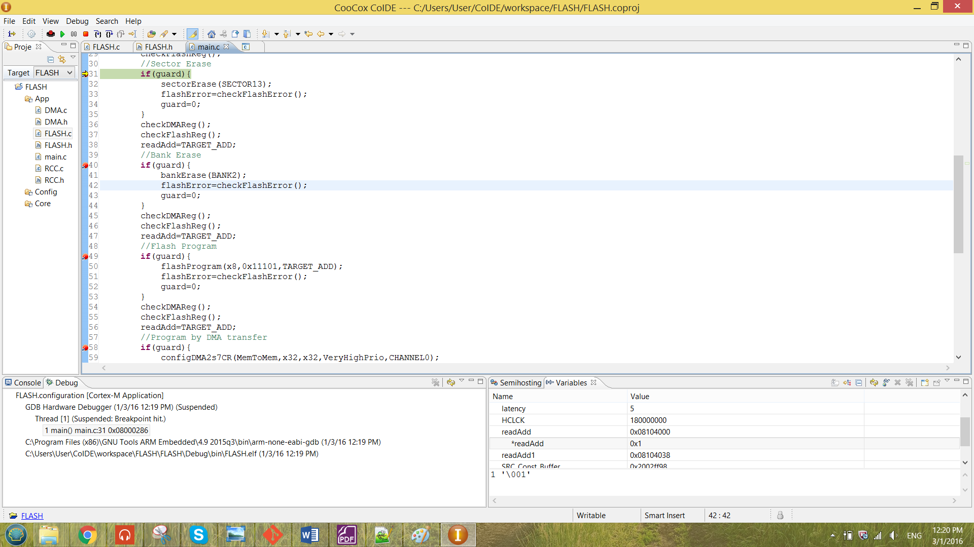

By doing that, it is programming the value with PSIZE of x8. The result observed for the configuration above is as shown below.

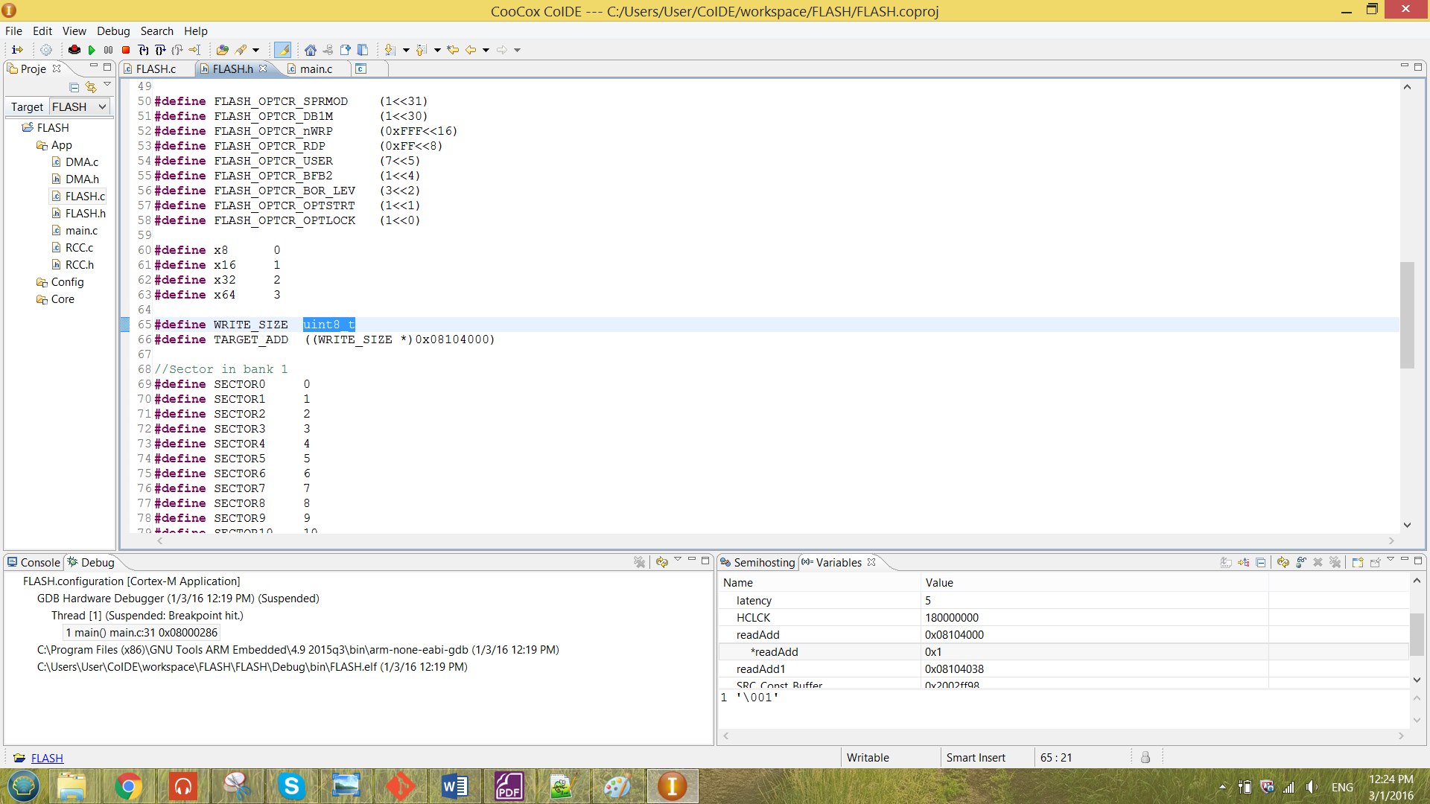

When the PSIZE choose to be x8, the program value seen will only the first 8-bit of the value. Hence, the result above proved that the program is functioning correctly.

An error has been forced to the program, the occurrence of the error will be caught by the function checkFlashError.

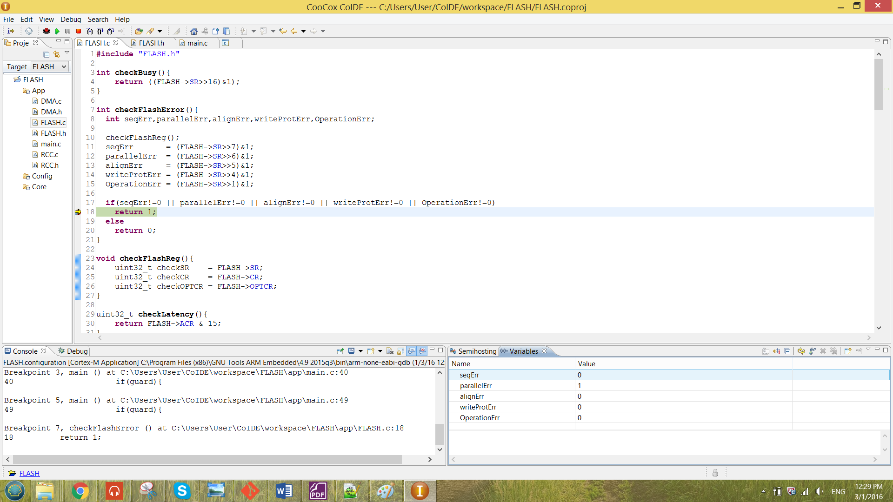

Figure 25 Error occurrance of the program



From the result shown above, the error was produced by configuring PSIZE x32 and the WRITE_SIZE is set to uint8_t. Thus, the error will show the parrallalism error in the SR register.